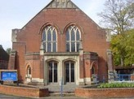
Salisbury Circuit 26/12
Amesbury Methodist Church
Minister: Deacon Selina Nisbett
email: selina.nisbett@methodist.org.uk 01980 669941
www.salisburymethodistcircuit.org.uk/churches/amesbury-methodist-church/
Newsletter for February 2026

Minister’s Letter

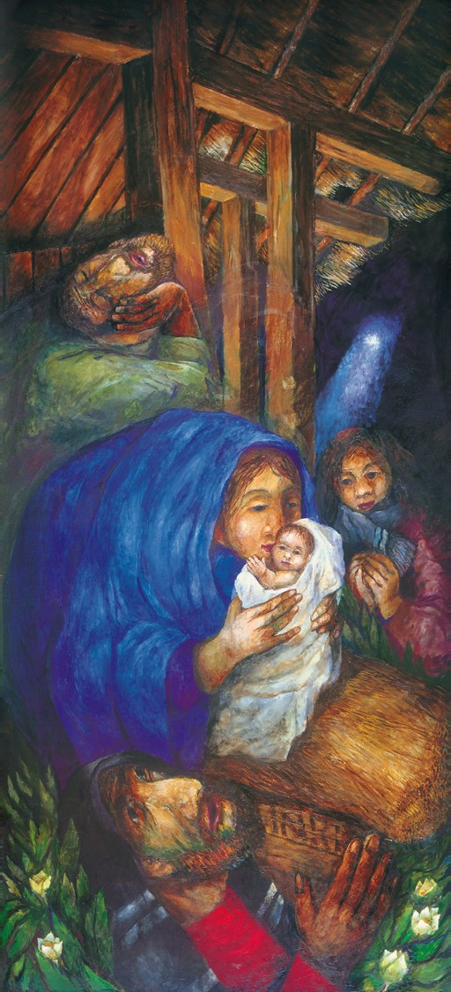
Dear Friends
Before we move into the season of Lent, we are invited to cast one brief glance back to Christmas on the 2nd February, when we recall the infant Jesus being presented at the temple by His parents, Mary and Joseph. Simeon, a devout and just elderly man, whose name means “he has heard,” is led by the Spirit to the temple. He forges his way towards the couple and takes the infant Jesus in his arms, identifying Him as the Saviour. Simeon then bursts into prophetic “song,” rejoicing that he has seen the sign of God’s salvation. “Sovereign Lord, as you have promised, you may now dismiss your servant in peace. For my eyes have seen your salvation, which you have prepared in the sight of all nations: a light for revelation to the Gentiles, and the glory of your people Israel.”
After a lifetime of yearning and waiting to see the long- promised Messiah, the sign of God’s salvation is in his arms and he declares Jesus not just Saviour of the Jewish nation, but for ALL people, ‘a light for revelation to the Gentiles” a light for all who are in darkness.
I’ve often wondered if he drank in the perfection of the baby, if he held Him up against his shoulder and gently patted Jesus on the back with grandfatherly affection, and if, when he looked into Jesus blinking eyes and hungry mouth, he needed to take a deep breath himself, because he delivers some devastating news to Mary, words which turn us towards the cross and our Lenten journey.
“This child is destined to cause many in Israel to fall, and many others to rise. He has been sent as a sign from God, but many will oppose Him. As a result, the deepest thoughts of many hearts will be revealed. And a sword will pierce your very soul.”
Through his painting, “The Rosenberg Nativity”, priest and artist, Seiger Koder, invites us to hold Simeon’s seemingly contradictory declarations together. In it, the manger of Bethlehem, points towards the cross of Calvary above. The cloth that has wrapped the new-born will become His burial shroud, and the wood of the manger, which cradles the infant Jesus, tells us that God has come close, but that it will later on bear the Saviour, emphasising to us just how far divine love will go. When we hold these together, we see the shape and depth and breadth of God’s love, which does not leave us in our suffering, but enters it with us, carries it, and redeems it.
If Advent and the incarnation taught us to watch for God, then Lent and Christ’s Passion teaches us to walk with God. May Köder’s nativity, remind us all that we are called to live “in between” these two pieces of wood, not just watching for Him in the places that are bright and easy, but walking with Him in the places that are hard and honest, in the fullest and comforting knowledge, that Christ does not call us to walk where He has not first walked Himself.
May God bless you richly as you live between the manger and the cross during this solemn and hoy season of Lent. With my love and prayers
Dcn Selina Nisbett

PRAYER POINTERS FOR THE MONTH

- For those of our congregation who are unable to get to church
- For our sisters and brothers in the other churches in Amesbury and their ministers
- For our armed service personnel and their families and chaplains
- For our young people preparing for Confirmation and Membership at AMC
- For those discerning lay leadership in our churches across the circuit

OUR ZAMBIA LINK


2026 is election year in Zambia; voting for President and Parliament is due in September. Zambia has been a democracy since independence in 1964; even during the 19 years when Zambia was a one-party state, there were plenty of rival candidates at parliamentary elections, and plenty of arguments about policy. Zambia has had different parties in power and different presidents, and the transfer of power has always been peaceful. But rivalries are fierce; violence between parties erupts, and so this year we are asked to pray, with our fellow Christians in Zambia, for peace, honesty and respect during the months of campaigning.
Give thanks that the rainy season has been sufficient for the crops; pray that the rains continue sufficient to bring Lake Kariba to the level that electricity generation will be more reliable. In the coming weeks, in United Church of Zambia congregations, there will be celebrations of “Green Harvest Sunday” giving thanks for the first fruits of the crops planted
five months earlier. The Girls’ Brigade company at St Andrew’s, Lusaka - the congregation we are linked with in prayer each week – enrolled a new group of girls in January.
January 16th was the 61st anniversary of the start of the United Church of Zambia and a special service of worship marked the end of the UCZ’s Diamond Anniversary year. It has been a year of growth as well as celebration – such growth in the number of congregations and members that a new Presbytery (equivalent to a District in British Methodism)
has been established – Lusaka East Presbytery, consisting of congregations in the eastern part of Lusaka and along 500 kilometres of the Great East Road, between Lusaka and the Luangwa River. Please continue to pray for the St Andrew’s, Lusaka, congregation of the UCZ, especially for the minister, Revd Theresa Matimba and her family, as they pray for us.
Cecil King
Sunday March 16
the
Amesbury Church Anniversary Service led by Rev. Rachel
Bending
Sunday March 30
to
Mothering Sunday
Sunday March 16
to
Amesbury Church Anniversary Service led by Rev. Rachel
Bending
Sunday March 30
to
Mothering Sunday
Sunday March 16
to
Amesbury Church Anniversary Service led by Rev. Rachel
Bending
Sunday March 30
the
Mothering Sunday

SERVICES OF WORSHIP February 2026 - Please pray for all those leading worship

- Sunday 1st February Mr John Pipet
- Sunday 8th February Rev Dr Philip Richter - Holy Communion
- Sunday 15th February Moira Burton – All Age Worship
- Wednesday 18th February Ash Wednesday - Churches Together at the Parish Church 11.am with Service with Holy Communion and ashing, and 7pm at the Parish Church - a Service of Penitence with hymns, sermon and ashing ceremony.
- Wednesday 18th February Ash Wednesday - Churches Together- at the Baptist Church Talk at 7.30pm – “Jesus the Evidence” please see notice below for further details
- Sunday 22nd February Dcn Selina Nisbett - Morning Worship with Baptism-1st Sunday in Lent

We extend a warm welcome to all and invite you to stay for refreshments, which will be served after the morning service. We usually take the Offering by having a plate in the Vestibule on your arrival to church and the Welcome Steward brings it up in the first hymn where the offering is dedicated during the Service. You can set up a Standing Order HSBC, Amesbury Methodist Church, Sort code: 40-08-25 Account No: 61117300

Action for Children
During the Christmas season we had several services which the collections were designated for ‘Action for Children’ The total amount collected was £246.45. Thank you to everyone who contributed to this worthwhile cause and making this an amazing total.
Vacancies
We still have Church offices to fill so if you feel you have the skills to offer or know someone who would be willing to take on one of the following roles , we would love to hear from you. Please speak to Selina or Derek
- Church Council secretary
- Gift Aid secretary

WELCOME CARDS!
In our desire to be especially welcoming to parents with small children, there are some cards in the welcome area to give to out to help them to feel welcome. Please do offer them to those with little ones.
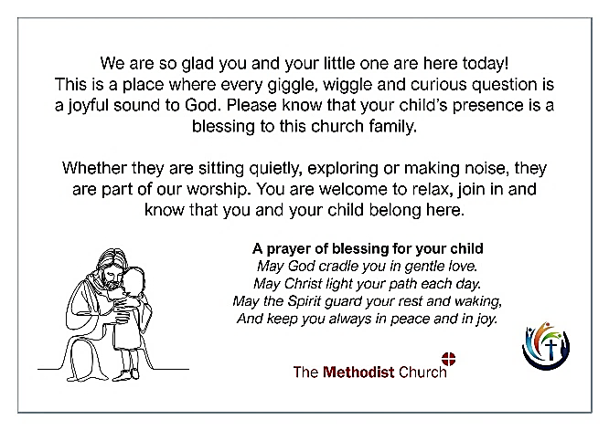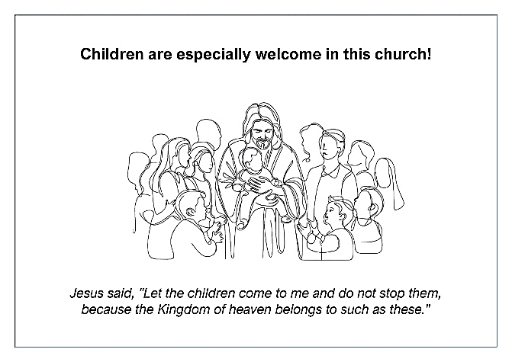
CHURCHES TOGETHER

Would very much like to put on Lent lunches with a short time of devotion and reflection before we eat. Please could you speak to Dcn. Selina if this is something you would like to be involved with. We cannot run it without a team of volunteers.
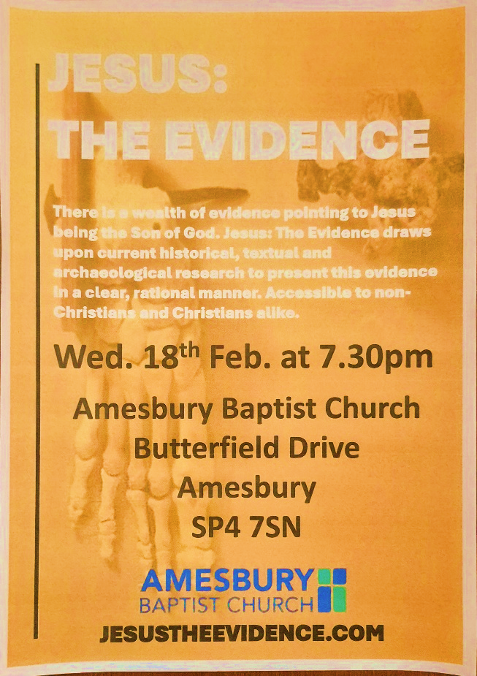
“Jesus the Evidence” is a one-evening live presentation which draws together current historical, textual and archaeological research to present the evidence for Jesus in a clear, rational and accessible manner.

The event lasts around 90 minutes. The first half is a structured presentation outlining the historical and logical basis for believing in Jesus’ life, death, and resurrection. The second half is an open Q&A, where attendees are free to ask any question—no topic is off limits.

It is an evening designed for those who are sceptical of religious claims, curious about Jesus or simply searching for truth in an age of doubt. Whether you’re an agnostic, atheist or believer seeking a firmer foundation for your faith, this project is built to engage with you respectfully and thoughtfully.

Ash Wednesday by Malcolm Guite
Receive this cross of ash upon your brow
Brought from the burning of Palm Sunday’s cross;

The forests of the world are burning now
And you make late repentance for the loss.
But all the trees of God would clap their hands,
The very stones themselves would shout and sing,
If you could covenant to love these lands
And recognize in Christ their lord and king.
He sees the slow destruction of those trees,
He weeps to see the ancient places burn,
And still you make what purchases you please
And still to dust and ashes you return.
But Hope could rise from ashes even now
Beginning with this sign upon your brow.

From “Word in the Wilderness”: A poem a day for Lent and Easter

Hall Bookings
For all bookings or enquiries contact Opal Webber the Community Hub Administrator who can be contacted on 07938711049; or by email amesburymethchurch@gmail.com

We have 2 large Halls and a small Meeting Room available for hire: Ideal for Family Parties, Groups, Exercise Classes, Dance Groups, etc. The Kitchen is large, spacious, and well equipped and complies with all Health & Safety Regulations.
For more details Contact the Stewards

MONDAY | 09.30 – 12.30 BH Afghan Community Hub  13.30 - 16.00 MH Beyond Dementia (formally The Alzheimer’s Support Group)  19.30 – 21.30 BH Scottish Country Dancing | TUESDAY | 11.00 – 13:00 BH Line Dancing with Julie  11.00 – 13.00 MH The Salisbury Food Bank  14.00 – 16.00 BH The Amesbury Archer’s Songsters  18.15 – 20.15 ALL rooms Girls Brigade
WEDNESDAY | 10.00 – 12.30 BH Pre-Natal Yoga  13.30 – 17.00 MH The Amesbury Bridge Group (every 3rd Wednesday)  17.00 – 20.15 BH Line Dancing with Julie | THURSDAY | 11.00 – 12.30 BH Line Dancing with Julie  13.00 – 15.00 MH The Salisbury Foodbank  14.00 – 16.30 QR Bible fellowship (1st & 3rd dates of the month)
FRIDAY | Cleaning at 6.00 pm | SATURDAY | 10.00 – 11:30 MH Coffee morning (2nd & 4th Saturday of the month)
BH = Back Hall, MH = Main Hall, YR = Youth Room, QR = Quiet Room

CONFIRMATION AND MEMBERSHIP CLASSES FOR OUR YOUNG PEOPLE (First 4 of 9 Sessions)
Youth room at the church- PLEASE ENSURE YOU HAVE PROVIDED PERMISSION LETTERS FOR EACH OF YOUR CHILDREN
- GOD - Creator 25th Jan 2.30 PM
- JESUS- Saviour 1st Feb 2.30 PM
- HOLY SPIRIT- Life Giver 8th Feb 2.30 PM

Amesbury Methodist Church CCLi licence no 206298.
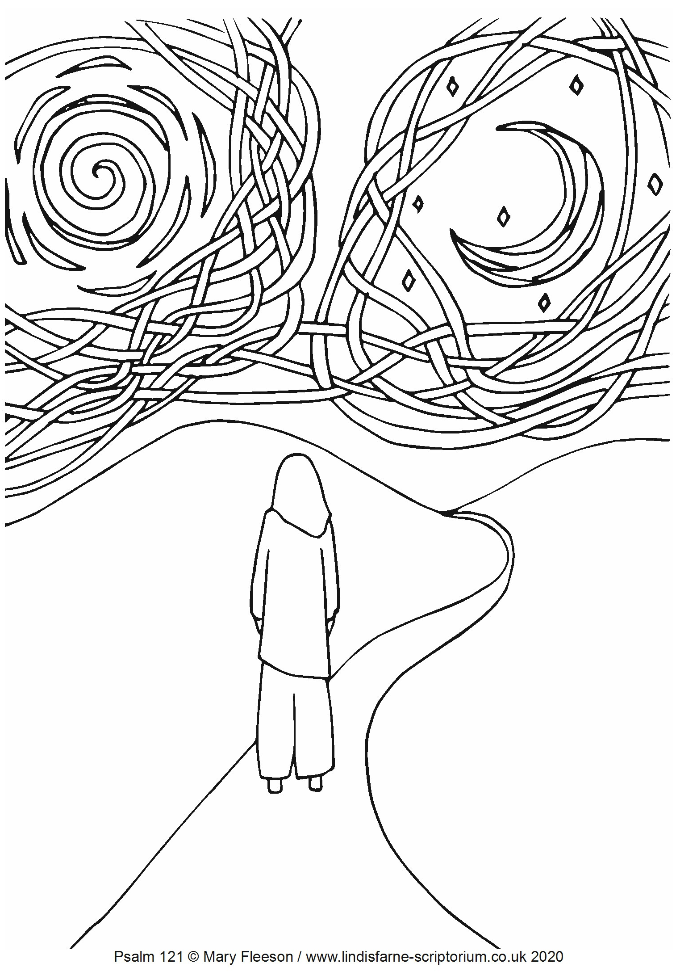
Meditative colouring for Lent from the pen of Mary Fleeson, for the young and young at heart!

I lift up my eyes to the mountains— where does my help come from?
My help comes from the Lord, the Maker of heaven and earth.

