
Salisbury Circuit 26/12
Amesbury Methodist Church
Minister: Deacon Selina Nisbett
email: selina.nisbett@methodist.org.uk 01980 669941
www.salisburymethodistcircuit.org.uk/churches/amesbury-methodist-church/
Newsletter for March 2026

Minister’s Letter

Dear Friends
As we journey through Lent and reflect upon the depth of God’s love for us, it is impossible not to consider the extraordinary truth that God’s love is both fierce and tender, both fatherly and motherly. In scripture, we often encounter God as a nurturing figure, one who comforts, holds, and cherishes us and it is this image that leads us into the mysterious and awe-inspiring truth of the Mothering of God.
Throughout history, many Christian mystics and theologians have pondered upon the idea of God as a mother, and one of the most profound voices in this conversation is that of Julian of Norwich. Julian was a 14th-century English anchoress, who experienced a time of critical illness and during that time she experienced some extraordinary visions which she wrote down and which offer to us an image of God that is deeply intimate. In her Revelations of Divine Love, Julian describes a God who nurtures and cares for us with the same compassion and love that a mother offers to her child.

In one of her most famous passages, Julian writes, “As truly as God is our Father, so truly God is our Mother.” This powerful statement invites us to see the divine not only as a protector and provider, but also as one who understands the pains and joys associated with birth and nurturing. In Julian’s view, God’s character transcends the anticipated and orthodox understanding of gender, and instead encompasses those usually associated with mothering.
For Julian, Christ’s sacrifice on the cross, as well as his incarnation, represent the ultimate act of self-giving love of a mother. She writes that God is “our true Mother, in whom we are endlessly and perfectly loved.” Such love is both protective and transformative, offering to us strength and a knowledge of being loved. During the middle ages, it was not uncommon to see images of female pelicans, piercing their breasts to feed their starving chicks with their blood, a powerful reminder of Christ’s sacrificial love for us.
This dual vision of God also invites us to reflect on the role of the Church, the Body of Christ, as a nurturing and maternal presence in our lives. The concept of Mother Church has been an enduring part of Christian tradition, emphasizing the Church’s role in giving birth to new life in Christ, guiding us in our spiritual growth, and providing us with the sustenance we need for our journey of faith. Just as a mother nourishes and cares for her children, so the Church seeks to nurture its members, in the offering of sacraments, and with the Word of God to sustain and grow our faith.

In this sense, “Mother Church” becomes a visible extension of God’s own mothering love, which enfolds us in care, protects us from spiritual harm, and calls us to a life of service and compassion. As Julian reminds us of God’s deep, abiding love, we are also reminded that the Church, with all its brokenness and beauty, is a place where God’s mothering love should be made manifest. It is a place where we should feel cared for and equipped, in order to extend that love to others in the world.
As we reflect on the Mothering of God this month, and celebrate our church anniversary on Mothering Sunday, may we be reminded that our faith is rooted in the great love of a God who is both powerful and gentle, who is both creator and nurturer, and may we, like Julian, grow in our understanding of God’s loving embrace, and share that love with those around us.
With love and blessings
Dcn Selina Nisbett

Illustration by Revd Ally Barratt
Stained glass window – Pelicans- Canterbury Cathedral

Prayer Pointers for the month
- For our young people preparing for the Confirmation on Easter Day
- For those who are ill and can no longer get to church
- For those who are seeking God, especially for our “START” group beginning after Easter
- For our ecumenical relationships, that we might support the events we are doing together

OUR ZAMBIA LINK


Continue to pray for honesty, integrity and peace in the campaigning which has begun for the presidential and parliamentary elections in August.
Give thanks for the sufficient rain which has fallen in the rainy season drawing to its end.
March in the United Church of Zambia (UCZ) will have three special Sundays:
8th: Women’s Christian Fellowship (WCF) Sunday, giving thanks for the WCF’s ministry in witness, in supporting bereaved families, in worship and in pastoral care.
15th: Youth Christian Fellowship (YCF) Sunday, celebrating the contribution of young people in witness and worship, in choirs and in drama, and in leadership of Girls’ Brigade, Boys’ Brigade and Sunday School.
22nd: Green Harvest Sunday: when God is honoured with offerings of the first fruits from the rainy season crops; thank God for sufficient rain this season.

Pray that all the arrangements for the April visit to England of Mr Whiteson Chenge will go smoothly. Mr Whiteson Chenge is the link person for our Southampton Methodist District’s link with the Lusaka Presbytery of the UCZ; he is to come to the Salisbury Circuit for three days towards the end of April. We are hoping that Whiteson will join us at AMC for a service and lunch. Date to be confirmed.

Our prayer link with St Andrew’s congregation in Lusaka. Pray for the minister, Revd Theresa Matimba, and her family. Pray for the congregation of St Andrew’s, as they pray for us.
Cecil King

Sunday March 16
the
Amesbury Church Anniversary Service led by Rev. Rachel
Bending
Sunday March 30
to
Mothering Sunday
Sunday March 16
to
Amesbury Church Anniversary Service led by Rev. Rachel
Bending
Sunday March 30
to
Mothering Sunday
Sunday March 16
to
Amesbury Church Anniversary Service led by Rev. Rachel
Bending
Sunday March 30
the
Mothering Sunday

Services for March including Holy Week and Easter Day- Please pray for all those leading worship
- Sunday 1st March Mr Malcolm Spencer
- Sunday 8th March Revd David Hollingsworth - Holy Communion
- Sunday 15th March Mothering Sunday and Church Anniversary – Dcn Selina Nisbett
- Sunday 22nd March Revd Christopher Jones
- Sunday 29th March Mrs Kathryn Newton
- Thursday 2nd April Maundy Thursday Holy Communion - joint at The Parish Church – 7.30 pm Dcn Selina Nisbett, preaching
- Friday 3rd April Good Friday- Good Friday Walk of Witness- further details to come
- Sunday 5th April Easter Day 10.30am- Easter Day Communion and Confirmation – Revd Rachel Bending District Chair and Dcn Selina Nisbett

We extend a warm welcome to all and invite you to stay for refreshments, which will be served after the morning service. We usually take the Offering by having a plate in the Vestibule on your arrival to church and the Welcome Steward brings it up in the first hymn where the offering is dedicated during the Service. You can set up a Standing Order HSBC, Amesbury Methodist Church, Sort code: 40-08-25 Account No: 61117300

A POEM FOR HOLY WEEK BY GODFRREY RUST
Communiqué
In the end we have to state
that no agreement was reached.
His stubborn opposition to compromise
was never breached.
Talks went on through the night
to meet Friday’s deadline.
Even the governor was woken early
to sign.
But no peace formula was found
at the eleventh hour.
Between the princes of earth and of heaven
there will be no sharing of power.
Every effort was made
to break down his reticence
but he would not join in any talks
and maintained his silence.
The release of prisoners
was the final opportunity.
It is reported that he did not take advantage
of the governor’s offer of clemency.
There is no bilateral statement
for the six o’clock news.
The communiqué displayed says simply
He is the King of the Jews.
On reflection it is clear
his agenda had been set from the start.
He planned a suicide mission
against the strongholds of the heart.
He did not negotiate with sin
when matters reached their head.
He would not de-commission his arms
but spread them wide instead.

Hall Bookings
For all bookings or enquiries contact Opal Webber the Community Hub Administrator who can be contacted on 07943076007; or by email amesburymethchurch@gmail.com

We have 2 large Halls and a small Meeting Room available for hire: Ideal for Family Parties, Groups, Exercise Classes, Dance Groups, etc. The Kitchen is large, spacious, and well equipped and complies with all Health & Safety Regulations.
For more details Contact the Stewards
MONDAY | 09.30 – 12.30 BH Afghan Community Hub  13.30 - 16.00 MH Beyond Dementia (formally The Alzheimer’s Support Group)  19.30 – 21.30 BH Scottish Country Dancing | TUESDAY | 11.00 – 13:00 BH Line Dancing with Julie  11.00 – 13.00 MH The Salisbury Food Bank  14.00 – 16.00 BH The Amesbury Archer’s Songsters  18.15 – 20.15 ALL rooms Girls Brigade
WEDNESDAY | 10.00 – 12.30 BH Pre-Natal Yoga  13.30 – 17.00 MH The Amesbury Bridge Group (every 3rd Wednesday)  16:30 – 20.15 BH Line Dancing with Julie | THURSDAY | 11.00 – 12.30 BH Line Dancing with Julie  13.00 – 15.00 MH The Salisbury Foodbank  14.00 – 16.30 QR Bible fellowship (1st & 3rd dates of the month)
FRIDAY | Cleaning at 6.00 pm | SATURDAY | 10.00 – 11:30 MH Coffee morning (14th & 28th March - 2nd & 4th Saturday of the month)
BH = Back Hall, MH = Main Hall, YR = Youth Room, QR = Quiet Room

Amesbury Methodist Church CCLi licence no 206298.


DATES FOR CONFIRMATION AND MEMBERSHIP CLASSES SUNDAYS AT 2.30PM
1ST MARCH- THE BIBLE
8TH MARCH- PRAYER AND WORSHIP
15TH MARCH - THE CHURCH
22ND MARCH- THE METHODIST WAY OF LIFE AND LOOKING AT THE CONFIRMATION SERVICE

THE CONFIRMATION SERVICE IS ON EASTER SUNDAY AT 10.30 AM
BRING ALONG YOUR FAMILIY AND FRIENDS TO CELEBRATE WITH YOU.

WORLDWIDE APPEALS – March 2026
An appeal from you to the authorities can help the victims of human rights violations. You can help free a prisoner of conscience or stop torture. Your message can bring liberty to a victim of disappearance. You may prevent an execution. The victims are many, the violators wide ranging. Every appeal counts.

Please visit the petition online –
https://www.amnesty.org/en/petition/free-moussa-tchangari/
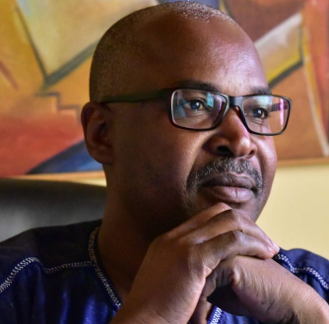

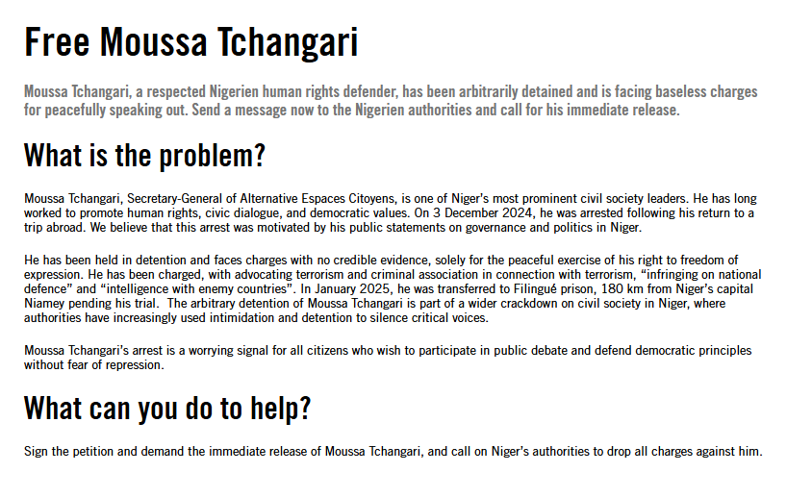

Amnesty International–Nobel Peace Prize 1977 UN Human Rights Prize 1978
For more information about the Salisbury branch
please call Tony Miller 01722 322791 - www.salisburyai.com

