
Salisbury Circuit 26/12
Amesbury Methodist Church
Minister: Deacon Selina Nisbett
email: selina.nisbett@methodist.org.uk 01980 669941
www.salisburymethodistcircuit.org.uk/churches/amesbury-methodist-church/
Newsletter for April 2026

Minister’s Letter

Dear Friends
As I write this, it is a bright sunny day, something we are so much in need of, and much to my relief, the clocks will change and evenings will be lighter again, but I am so very conscious that as we watch the news and pray for poor souls caught up in unimaginable wars not of their making, we may feel the light and hope to which we cling, slip from our grasp, dragging us down into a morass of worry and despair.
Having led our young people’s confirmation class, which was an extraordinary privilege, I have come to know just how conscious they are of the fragile state of our world, and how worried they are by the seemingly insurmountable issues relating to war, climate change, genocide, racism, the persecution of refugees and those of other faiths and sexualities, as well as poverty and homelessness. They speak in a way that is both profound and mature, and reflect the commitment of the Methodist Church to shine a light into the darkness and to be a justice seeking church.
During the second World War, paintings from the National Gallery in London were moved to various places around the country in order to preserve them, but while London was being besieged by the misery and darkness of bombs and blackouts, the gallery’s trustees, decided that one picture a month should be returned and hung for public exhibition, for the morale of the people. It was a moment when they could hold onto to some normality in their lives. The first painting chosen by the public was on the face of it, a surprising choice. It was painted by Titian and was called “Noli me Tangere” or “Do not cling to me.”
It depicts what we might perceive as a heartbreaking moment from the Gospel of John, after Christ’s resurrection from the dead. It is the moment when Mary Magdalene, distraught at finding the tomb where Jesus was laid, is empty, mistakes Jesus for the gardener, and asks where his body is. As the sheep know the shepherd’s voice, Jesus speaks her name, “Mary” and she instantly recognizes him, and instinctively reaches out her hand in wonder and amazement to him, but Jesus almost rebuffs her, saying;
“Do not cling to me, (or noli me tangere in Latin), for I haven’t yet ascended to the Father. But go find my brothers and tell them, I am ascending to my Father and your Father, to my God and your God.”
In these words, Jesus reminds Mary that he has things that need to be done, and as the first one to witness the resurrected Jesus, she was given the joyous task of proclaiming the good news. She is transformed from his faithful follower to privileged witness, and on to apostle to the apostles.
At first sight it seems quite a strange picture for people besieged by war, to have chosen, but the transformation taking place within that encounter must have spoken to them powerfully. Jesus is there in a new way; it is not a resetting of the clock, back to what had been, rather it is a step into a new reality where love and life has conquered death and darkness. For those living through the devastation of war, the element of transformation, must have served as a powerful reminder, that even in their darkest time, there was always the possibility of a new reality.
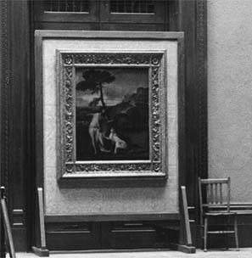
May we too, in these dark and worrying times, let go and stand defiantly in the light of the empty cross, which audaciously proclaims that the darkness wherever it is, cannot and will never triumph over the power of the joyful reality, that Christ is indeed risen.
The painting, “Noli me Tangere” as it was hanging during WW2. During air raid warnings and at night, it was removed from the wall and taken down to the underground shelter.
Wishing you all a blessed Eastertide!
With love and blessings
Dcn SELINA NISBETT

PRAYER POINTERS- PLEASE PRAY FOR
- Our new members of AMC, that they may continue to walk in the way of Christ.
- For our sisters and brothers who can no longer get to church, through illness, fragility or caring responsibilities- may they know God’s peace and presence
- We give thanks to God for the precious ecumenical links re-established through the Lent lunches at AMC, for new friendships made, and stories, reflections and food shared.
- We pray for those in our communities who are “othered” and feel marginalised, that we might respond with Christlike grace and love.
- We pray for safe travels for Whiteson as he travels to the UK to be with us in the month of April, that we may have opportunities to learn and grow together.

A poem by Ann Lewin on Jesus encounter
with Mary Magdelene


“Do not cling .....
Let me be bigger than your
Heart can hold.
Rise with me to a
Larger vision.

OUR ZAMBIA LINK

April begins with Holy Week and then the Easter season. Here, we are in Spring time, the end of winter and the beginning of warmer weather. In Zambia, April is the transition from the warm wet season to the cooler dry months.

For many congregations in Zambia, Palm Sunday is the biggest act of public witness in the year, with outdoor worship and processions, often with different denominations marching and singing together.

On Easter Sunday, all the choirs and fellowships and the Boys’ Brigade band will be involved in thrilling worship of Jesus Christ, our risen Lord.

We are asked to pray in the next few months about the general election in Zambia. On 13th August
Zambians will vote in local government, in national parliament and in presidential elections. At present the Electoral Commission is delineating new constituency boundaries, increasing the number of National Assembly members by nearly 45%, from 156 to 226. The government’s hope is that this will accurately reflect the population distribution and produce more diverse and inclusive representation.

Pray that the huge administrative tasks of creating 70 more constituencies and of running the election will go smoothly, and pray for honesty and integrity in the pre-election campaigning.

In April, we hope that Mr Whiteson Chenge will visit the Salisbury circuit, staying here from 25th to 29th, and meeting people of the congregations linked with congregations in Lusaka. Whiteson is the link person of the United Church of Zambia (UCZ) Lusaka Presbytery with our Southampton methodist District. Pray for travelling blessings for Whiteson, as we look forward to meeting him and sharing his experience and wisdom.

Whiteson is a member of the congregation we are linked with – St Andrew’s UCZ, Lusaka. Pray for the minister – Revd Theresa Matimba – and her family, and pray for the life and witness of St Andrew’s congregation, as they pray for us each week.
Cecil King

PRAYERS FROM OUR BROTHERS AND SISTERS IN THE UCZ

- Praise God for Green Harvest Sunday (March 22), for the thankful worship and generous offering.
- Pray for the witness and worship on Palm Sunday and during the Holy Week that people will be drawn to the cross of Christ and know God's forgiving love.
- Pray for young people during the school holidays.
- At St Andrew's, pray for the minister, Revd Theresa Matimba, and her family and for the officers and girls of the Girls' Brigade, as they pray for us.



Sunday March 16
the
Amesbury Church Anniversary Service led by Rev. Rachel
Bending
Sunday March 30
to
Mothering Sunday
Sunday March 16
to
Amesbury Church Anniversary Service led by Rev. Rachel
Bending
Sunday March 30
to
Mothering Sunday
Sunday March 16
to
Amesbury Church Anniversary Service led by Rev. Rachel
Bending
Sunday March 30
the
Mothering Sunday
Services for April - Please pray for all those leading worship

- Thursday 2nd April- Maundy Thursday Holy Communion- Joint service at The Parish Church – 7.30 pm Dcn Selina Nisbett- preaching

- Friday 3rd April Good Friday- Good Friday Walk of Witness- gather at 10am by the Tree of Light- HOT CROSS BUNS AND REFRESHMENTS WILL BE SERVED AT AMESBURY METHODIST CHURCH FOLLOWING THE SERVICE.

- Sunday 5thApril Easter Day 10.30am- Easter Day Communion and Confirmation
With Revd Rachel Bending, District Chair and Dcn Selina Nisbett
"You are invited to bring along a flower on Easter Sunday to decorate the Cross."
- Sunday 12th April 10.30 am Morning worship- Dcn Selina Nisbett
- Sunday 19th April 10.30 am Morning worship- Revd Dorothy Pipet
- Sunday 26th April-10.30 am Morning worship – Dcn Selina Nisbett – (Mr Whiteson Chenge, from the Lusaka Presbytery of the UCZ will be visiting AMC in the afternoon)


We offer our congratulations to 8 of our young people who were newly confirmed on Easter Day and have been received as members of the Methodist Church at Amesbury in their own right! We promise to continue to pray for you all.

We extend a warm welcome to all and invite you to stay for refreshments, which will be served after the morning service. We usually take the Offering by having a plate in the Vestibule on your arrival to church and the Welcome Steward brings it up in the first hymn where the offering is dedicated during the Service. You can set up a Standing Order HSBC, Amesbury Methodist Church, Sort code: 40-08-25 Account No: 61117300

Justice and Peace meeting
Wednesday April 8th 2026 at 2pm in the Back Room at Bemerton Methodist Church.
All are welcome

REQUESTS/REMINDERS/ REJOICING

REQUEST ******Mr Whiteson Chenge from UCZ will be visiting us on the 26th April in the afternoon. It would be good to have a few representative people from our congregation to meet with him and to prepare some tea and cake for his visit. Please let Selina know if you could help or would like to come. ******

REMINDER - GDPR AND THE PRAYER BOOK
Before you put the name of the person you wish to be prayed for:
- Please ask their permission first
- Please do not use the person’s full name (God knows who they are)
- Please do not disclose anything about their health condition (God knows their need)
- Please sign your name after you have written your prayer intention
REJOICING- A BIG THANK YOU to those at AMC who have helped in many ways with the Lent lunches on a Friday. They have been appreciated by all who have come, and each week we have had representatives of all 4 churches in Amesbury. Thank you too for your generosity- I will let everyone in the churches know what we have raised for Christian Aid once we have banked the money.

Hall Bookings
For all bookings or enquiries contact Opal Webber the Community Hub Administrator who can be contacted on 07938711049; or by email amesburymethchurch@gmail.com

We have 2 large Halls and a small Meeting Room available for hire: Ideal for Family Parties, Groups, Exercise Classes, Dance Groups, etc. The Kitchen is large, spacious, and well equipped and complies with all Health & Safety Regulations.
For more details Contact the Stewards
MONDAY | 10.00 – 12.00 BH Afghan Community Hub  13.30 - 16.00 MH Beyond Dementia (formally The Alzheimer’s Support Group)  19.30 – 21.30 BH Scottish Country Dancing | TUESDAY | 11.00 – 13:00 BH Line Dancing with Julie  11.00 – 13.00 MH The Salisbury Food Bank  14.00 – 16.00 BH The Amesbury Archer’s Songsters  18.15 – 20.15 ALL rooms Girls Brigade (Term-time only)
WEDNESDAY | 10.00 – 11.00 BH Pre-Natal Yoga  13.30 – 17.00 MH The Amesbury Bridge Group (every 3rd Wednesday)  16:30 – 20.15 BH Line Dancing with Julie | THURSDAY | 11.00 – 12.30 BH Line Dancing with Julie  13.00 – 15.00 MH The Salisbury Foodbank  14.00 – 16.30 QR Bible fellowship (1st & 3rd dates of the month)
FRIDAY | Cleaning at 6.00 pm | SATURDAY | 10.00 – 11:30 MH Coffee morning (13th & 27th April - 2nd & 4th Saturday of the month)
BH = Back Hall, MH = Main Hall, YR = Youth Room, QR = Quiet Room



Amesbury Methodist Church CCLi licence no 206298.



WORLDWIDE APPEALS – April 2026
An appeal from you to the authorities can help the victims of human rights violations. You can help free a prisoner of conscience or stop torture. Your message can bring liberty to a victim of disappearance. You may prevent an execution. The victims are many, the violators wide ranging. Every appeal counts.

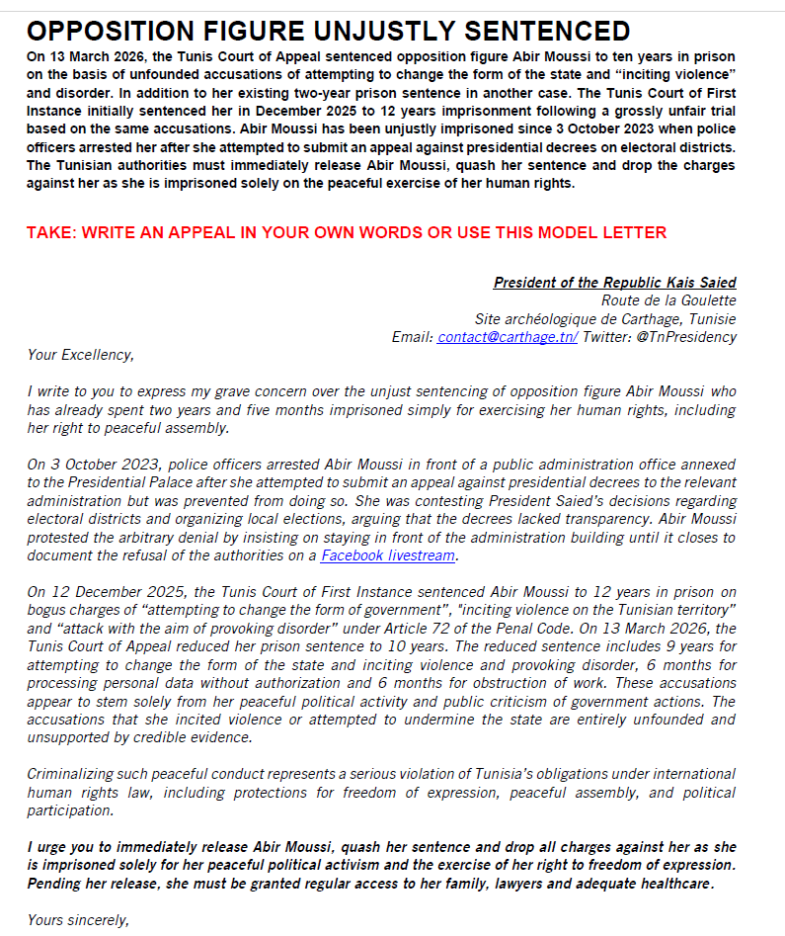
Amnesty International–Nobel Peace Prize 1977 UN Human Rights Prize 1978
For more information about the Salisbury branch
please call Tony Miller 01722 322791 - www.salisburyai.com

