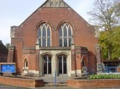
Salisbury Circuit 26/12
Amesbury Methodist Church
Minister: Deacon Selina Nisbett
email: selina.nisbett@methodist.org.uk 01980 669941
www.salisburymethodistcircuit.org.uk/churches/amesbury-methodist-church/
Newsletter for June 2026

Minister’s Letter

Dear Friends,
A couple of years ago I took a DNA test which revealed who my ancestors were and where they came from, and the results plotted the journeys they took in search of a better life. Some of them, fled Ireland for Scotland due to dire poverty, and on the 30th October 1839 they left Glasgow aboard a ship called the Bengal Merchant, and became the first pioneers from Scotland to arrive in New Zealand. They went steerage class, so it was far from an easy journey, finally arriving off Petone Beach in Wellington in February 1840.
Remarkably other results showed that my ancestors thousands of years before, had come from what we commonly refer to as the Steppes of Russia, showing a route overland and by sea, to settle in Ireland, Germany, and Spain. Migration has always been part of the human story, and in the Bible we see numerous journeys being made.
Abraham, in obedience to God, left his homeland in Ur and all that he would have known, to journey the land of Canaan. Moses led the Israelites out of slavery in Egypt towards the Promised Land, a journey symbolizing liberation and faith. Whilst Joseph’s journey to Egypt is a harrowing one for him, it leads on to the protection and preservation of Israel, from famine and danger. Ruth, a Moabite and therefore a foreigner or sojourner, travelled with her mother-in-law Naomi, an Israelite woman, to Bethlehem, and gleans from the fields according to the Mosaic law, a law which stated, “when you reap the harvest of your land, you shall not reap your field right up to its edge, nor shall you gather the gleanings after your harvest. You shall leave them for the poor and for the sojourner.”
Perhaps the most significant “journey” to be made was God coming to earth in Jesus to bridge the gap between heaven and humanity, and woven into that narrative, is the account of Mary and Joseph, fleeing to Egypt for safety. The ministry of Jesus himself, is marked by journeys, and the Apostle Paul travelled extensively to spread the gospel. The Bible is therefore marked by migration, and nearly every major Biblical figure’s life is defined by a journey.
These journeys in scripture are significant because they give us a lens through which to evaluate our response to refugees today in this country and around the world. The Exodus reminds us of people fleeing violence and oppression; Ruth’s journey highlights the need for food, work and dignity and Jesus refugee experience reminds us of people escaping political violence. Scripture lays upon our hearts, a moral expectation of compassion, justice and welcome to those who are displaced, and challenge us to push against the fear based narratives, reminding us that they are quite simply our neighbours, not outsiders.
During Refugee Week which runs from June 15th-21st may we all remember, pray and reach out to those who have left all they know and now reside in “strange lands” and remind ourselves of the words in Matthew 25, “For I was hungry and you gave me something to eat, I was thirsty and you gave me something to drink, I was a stranger and you invited me in…”

Love and God bless

Dcn. Selina Nisbett

PRAYER POINTERS- please pray for……..
- the Afghan Hub and all those who are far from home and struggling with various barriers, that we might be compassionate and welcoming.
- For our ministry to our children and young people in our Junior Church
- Give great thanks to God for all those who have taken up the many leadership roles within the church, and pray that God will inspire others to offer of themselves
- For our Girl’s Brigade and their leaders; for the successful and joyful Open Evening in May, that they may continue to know the faithfulness and love of God in all that they do.
- For our Ecumenical brothers and sisters in Amesbury and their leaders, for Fr George at Christ the King, Revd Barry Davis at the Baptist Church and Revd Kelvin Inglis at St Mary and St Melor.

You are the light of the world! Let your light shine!

OUR ZAMBIA LINK
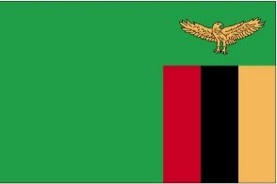
Zambia’s National Assembly has been dissolved, and candidates are being chosen for local, national and presidential elections in August. Pray that the election campaigns will be peaceful and honest.

In the United Church of Zambia (UCZ) there will be joy and renewal of commitment at the ordination of new ministers in Kabwe on June 7th. Pray for the ministers to be ordained and for the congregations they work with.

Each year at the end of June the UCZ holds a nationwide prayer meeting – open air prayer meetings linked digitally, praying for God’s blessing on Zambia, praying that more people will come to know and follow Jesus – and this year praying about the elections. This year’s nationwide prayer meeting will be on Saturday, June 27th.

On Sunday, 28th June, UCZ congregations will be praying for and learning about Theological Extension in Zambia (TEEZ). TEEZ was started in 1979 by the United Church of Zambia, the Churches of Christ and the Anglican Church in Zambia, to provide theological education and lay training for church people all over the country. TEEZ creates and distributes course material which people study in their own homes and work through in local groups with a trained local tutor. This is an ideal way of learning in a vast country where travel is not easy, and it means that training is done in each person’s local area, language and congregation rather than in a residential college far away from the place where a person ministers. Many people have been and are being trained for ministries like local preaching, worship leading, teaching in Sunday School and membership classes and leading Bible study groups.

Give thanks for the visit of Mr Whiteson Chenge, who visited us in May, and give thanks for his safe return home to Lusaka. Whiteson worships at St Andrew’s UCZ congregation in Lusaka; please pray for St Andrew’s UCZ congregation as they pray for us, and please pray for their minister, Revd Theresa Matimba, and her family.

Cecil King

Sunday March 16
the
Amesbury Church Anniversary Service led by Rev. Rachel
Bending
Sunday March 30
to
Mothering Sunday
Sunday March 16
to
Amesbury Church Anniversary Service led by Rev. Rachel
Bending
Sunday March 30
to
Mothering Sunday
Sunday March 16
to
Amesbury Church Anniversary Service led by Rev. Rachel
Bending
Sunday March 30
the
Mothering Sunday

Services for June - Please pray for all those leading worship

- Sunday 7th June 10.30 am - Morning Worship - Moira Burton
- Sunday 14th June 10.30 am - Holy Communion - Revd Dr Mark Cheetham
- Sunday 21st June 10.30 am - All Age Service - Dan Bishop
- Sunday 28th June 10.30 am - Mission Service - Dcn. Selina Nisbett

During our forthcoming Mission Services, we will be discerning what God is calling us to do through the gift that is Amesbury Methodist Church

We extend a warm welcome to all and invite you to stay for refreshments, which will be served after the morning service. We usually take the Offering by having a plate in the Vestibule on your arrival to church and the Welcome Steward brings it up in the first hymn where the offering is dedicated during the Service. You can set up a Standing Order HSBC, Amesbury Methodist Church, Sort code: 40-08-25 Account No: 61117300

THE COST OF RUNNING THE CHURCH.
We have recently been asked to increase our Assessment to the circuit. Our Assessment at Amesbury Methodist Church is based upon a formular comprising of attendances and gift aid return and membership, which for the coming year 2026 – 2027 is £24,000.00 (we were asked for a lot more but following discussions we reduced it, which means the circuit is subsidizing us).

For those not familiar with the term Assessment, this is the amount we pay into the circuit fund which goes towards paying our ministers stipends; housing allowance, missions, circuit admin and various other running costs This has prompted us to review our finances as we are struggling like many other Churches to pay our way.

Our expenditure this financial year 2025-2026 is likely to be in the region of £37,876.00 which does not include repairs . Our outgoings have increased due to outside contractors doing Church Cleaning and grass cutting.

Budget Breakdown
Assessments £22,500.00
Utilities- Gas, Water, Electricity & insurance £7,000.00
Contribution towards community hub administrator £1,276.00
Cleaning £4,800.00
Grass cutting £1,300.00
Sundry expenses £1,000.00
Total Expenditure £37,876.00

Average monthly expenditure £3,156.33

Our income for a typical month based in April 2026
Direct bank debits £734.00
Sunday collections for the month £610.00
Hire of Halls & coffee mornings (average) £1,400.00
Total monthly income £2,744.00

We are therefore showing a shortfall of £412.33 per month

As an average per member it costs £15.00 per week. We are all too aware of the cost of living crisis and what we are not saying is we expect everyone to pay this amount. Whilst for some on fixed incomes we appreciate that you contribute all you can afford but there may be some who could contribute more.

What does the Bible say about Financial Giving?
Malachi 3 verses 7-10 emphasizes that money and faith are connected, challenges selfishness and calls people back to faithfulness and obedience to God.

“Return to Me, and I will return to you,” says the Lord Almighty. But you ask, “How can we return?” “Will people withhold from God what belongs to Him? Yet you have held back what was meant for Me. Still you ask, ‘What have we held back?’ In tithes and offerings. As a nation, you have experienced the hardship that comes from turning away from My ways, because you have withheld from Me. Bring the full tithe into the storehouse so there will be enough in My house. Test Me in this,” says the Lord Almighty, “and see whether I will not open the windows of heaven for you and pour out blessing beyond what you can contain.”

1 Corinthians 16:1–2 supports the idea of consistent and proportional giving.

“Now about the collection for the Lord’s people: Do what I told the Galatian churches to do. On the first day of every week, each one of you should set aside a sum of money in keeping with your income, saving it up, so that when I come no collections will have to be made.”

Acts 2:44–45 describes early Christians sharing resources so no one was in need.

“All the believers were together and had everything in common. They sold property and possessions to give to anyone who had need.”

In summary we are called to
- give willingly,
- give generously,
- give consistently
- and remember that giving is part of our worship

Our Financial Strengths
We can put them to the test by asking ourselves the following
- Am I inviting the holy spirit into my giving?
- Am I returning to the Lord that which belongs to him?
- Am I a channel for God’s Storehouse?
- Am I opening up the floodgates of heaven?
- I am trusting God with my tithes and offerings?

If you have not already considered giving your offering by monthly direct debit, now is a good time. It helps the Church with cash flow and a means of regular income.
Details of Amesbury Church bank as follows;
Account number; 61117300
Sort Code; 40-08-25
Account name Amesbury Methodist Church

Thank you for prayerfully considering your giving to AMC.

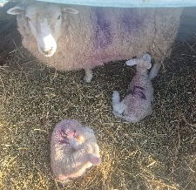

On a glorious sunny evening in May, I was able to go with Girl’s Brigade to their lambing evening at the Farm off Countess Rd. I had some delightful conversations with the girls and we all learnt a lot about sheep- who knew that ewes stole lambs from other ewes, and that some ewes take a real dislike to their babies. There were a few of them, so some of the girls were able to bottle feed a couple of lambs that needed extra TLC. We learnt that ewes dig a nest to give birth in and stay there for 12 hours after delivering their lambs. We were also blessed with the opportunity to see twin lambs being born and an attentive mum cleaning them off. Thank you to Anthea and Jane and all the leaders for inviting me along to such a special evening. Dcn Selina Nisbett

Hall Bookings
For all bookings or enquiries contact Opal Webber the Community Hub Administrator who can be contacted on 07943076007; or by email amesburymethchurch@gmail.com

We have 2 large Halls and a small Meeting Room available for hire: Ideal for Family Parties, Groups, Exercise Classes, Dance Groups, etc. The Kitchen is large, spacious, and well equipped and complies with all Health & Safety Regulations.
For more details Contact the Stewards
MONDAY | 10.00 – 12.00 BH Afghan Community Hub  13.30 - 16.00 MH Beyond Dementia  19.30 – 21.30 BH Scottish Country Dancing | TUESDAY | 11.00 – 12:30 BH Line Dancing with Julie  11.00 – 13.00 MH The Salisbury Food Bank  14.00 – 16.00 MH The Amesbury Archer’s Songsters  18.15 – 20.15 ALL rooms Girls Brigade (Term-time only)
WEDNESDAY | 10.00 – 12.30 BH Pre-Natal Yoga  16:30 – 20.15 BH Line Dancing with Julie | THURSDAY | 11.00 – 12.30 BH Line Dancing with Julie  13.00 – 15.00 MH The Salisbury Foodbank  14.00 – 16.30 QR Bible fellowship (1st & 3rd dates of the month)
FRIDAY | Cleaning at 6.00 pm | SATURDAY | 10.00 – 11:30 MH Coffee morning 13th & 27th June (2nd & 4th Saturday of the month)  14.00 – 17.00 BH (20th only) Line Dancing with Julie
BH = Back Hall, MH = Main Hall, YR = Youth Room, QR = Quiet Room

Amesbury Methodist Church CCLi licence no 206298.


WORLDWIDE APPEALS – June 2026
An appeal from you to the authorities can help the victims of human rights violations.
You can help free a prisoner of conscience or stop torture. Your message can bring liberty
to a victim of disappearance. You may prevent an execution.

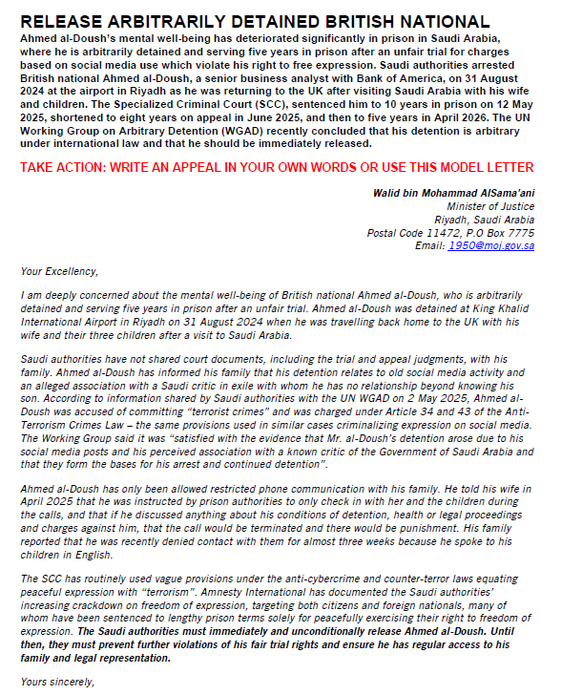
The victims are many, the violators wide ranging. Every appeal counts.
Amnesty International–Nobel Peace Prize 1977 UN Human Rights Prize 1978
For more information about the Salisbury branch
please call Tony Miller 01722 322791 - www.salisburyai.com

