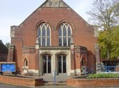
Salisbury Circuit 26/12
Amesbury Methodist Church
Minister: Deacon Selina Nisbett
email: selina.nisbett@methodist.org.uk 01980 669941
www.salisburymethodistcircuit.org.uk/churches/amesbury-methodist-church/
Newsletter for May 2026

Minister’s Letter

Dear Friends
I wonder if you have ever sat on an underground station in London, and before the train arrives, you experience a warm, strong rushing wind, which indicates the imminency of the train arriving. It is something that has always fascinated me and something which I always think of when we celebrate Pentecost and the arrival of the Holy Spirit upon the disciples.
In the Hebrew scriptures, the Spirit is known as “ruach,” God’s personal presence of energy, life and vitality and in the creation narrative we are told that it hovers over the deep, bringing order out of chaos, and it breathes life into humanity, giving ALL people a connection to the divine. At the baptism of Jesus, we are told that the Spirit rested upon him and it raises him to new life to begin the work of the new creation.
On Sunday 24th May we shall be celebrating Pentecost, the coming of the Holy Spirit, also known by some as “the birthday of the church,” and on that day Methodists also mark what has come to be known as Aldersgate Sunday, when John Wesley, struggling with his own faith, had an extraordinary experience which transformed his inner life and faith. Undoubtedly it came as a great surprise to him, and he reflected in his journal writing,
“In the evening I went very unwillingly to a society in Aldersgate Street, where one was reading Luther’s preface to the Epistle to the Romans. About a quarter before nine, while he was describing the change which God works in the heart through faith in Christ, I felt my heart strangely warmed. I felt I did trust in Christ, Christ alone, for salvation; and an assurance was given me that He had taken away my sins, even mine, and saved me from the law of sin and death.”
It would be true to say that John Wesley had known God for himself intellectually, but this moment of being “born again”, gave him a deeply profound assurance that he needed; now his intuition/ “knowing” came to know God with a quiet intensity, right down into the depths of his soul. Whilst he continued to have difficulties from time to time, (don’t we all!), this assurance, undoubtedly strengthened him, to such an extent, that it changed his life. This spiritual awakening, gave his ministry a reinvigorated intensity, and he became even more committed to spreading the message of salvation. His itinerant preaching style which grew from this moment, was and still is, the hallmark of the Methodist Church, and which he believed was so crucial to the spiritual awakening of the people. By the time of his death, it is thought he travelled some 250, 000 miles, primarily on horseback, and brought about the movement of the people called Methodists.
Similarly, on the day of Pentecost, the disciples, who were waiting prayerfully in the Upper room, and who we might say, knew God in Jesus, in an intellectual and corporeal way, also had a deeply profound experience, but one that was both a physical and spiritual experience. It was as if tongues of fire rested upon their heads, and the room shook violently, with a powerful wind, and they were empowered and emboldened to not just leave the safety and security of the Upper room, but to preach the gospel in languages other than their own. Their hearts must have skipped a beat or two as the Spirit was “activated” within them, and discovered hidden depths within themselves. It was an utterly transformative experience that they will have undoubtedly remembered to the end of their earthly days.
Two contrasting experiences of the Spirit, one quiet, steadying and affirming, but emboldening and life giving nevertheless; the other more obvious, giving courage and energy, when courage and energy were needed, both deeply transformative experiences in nature. I wonder how you yourselves might have experienced the Holy Spirit in your lives? Perhaps like the dramatic outpouring on Pentecost, or more quietly like John Wesley’s transformation? And I wonder if you would be prepared to share your thoughts in our service on the 24th May?
With love and blessings
Dcn. SELINA NISBETT

OUR ZAMBIA LINK

May is the beginning of the dry season. In the coming five months there will be a lot more out of door activities. In United Church of Zambia (UCZ) congregations, there will be church weddings during these five months.

During May, UCZ congregations run evangelism campaigns, taking advantage of the dry weather to hold outdoor worship and meetings, as well as door to door visiting and leafleting.

During the next fifteen weeks – up to election day on 13th August, there will be campaigning for the election of the President, the National Assembly and local authorities. There are seventy new constituencies, as the next National Assembly will have 113 more members than the present one and will also include nominated female, young and disabled members. We are asked to pray for honesty and integrity in the campaigning

As in the UK, Zambians will have two holidays in May – Labour Day on 4th May and Africa Freedom Day on 25th May.

Africa Freedom Day commemorates the founding of the Organisation of African Unity (OAU) in 1963 and celebrates the liberation of African nations from European rule. In the UCZ, it is a day for reflecting on the need for the church to change ways of mission as the world changes, hence the UCZ’s current motto “Changing the Narrative”.

In church, Easter is being celebrated, up until Pentecost on 24th May. Pray, with our sisters and brothers in the UCZ, that we shall know the risen Jesus with us in all that we do.

Cecil King
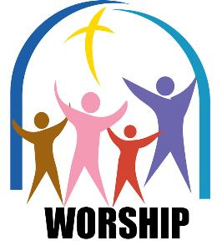
Sunday March 16
the
Amesbury Church Anniversary Service led by Rev. Rachel
Bending
Sunday March 30
to
Mothering Sunday
Sunday March 16
to
Amesbury Church Anniversary Service led by Rev. Rachel
Bending
Sunday March 30
to
Mothering Sunday
Sunday March 16
to
Amesbury Church Anniversary Service led by Rev. Rachel
Bending
Sunday March 30
the
Mothering Sunday
Services for May - Please pray for all those leading worship

- Sunday May 3rd 10.30 am – All Age Worship – Sue Holmes
- Sunday May 10th 10.30 am - Holy Communion – Padre Richard Smith
- Sunday May 17th 10.30 am Morning Worship – Mr Steven Irish
- Sunday May 24th 10.30 am Morning Worship for Pentecost Sunday - Dcn. Selina Nisbett
- Sunday May 31st 10.30 am Morning Worship – Mr Dudley Coates

********AN IMPORTANT DATE FOR YOUR DIARY*******
On SUNDAY 24th MAY after our morning service we will be holding our General Church Meeting, when we will:
- Have a conversation on the ministry and witness of our church
- Look at our financial affairs
- Appointment church stewards
- Elect representatives to Church Council
PLEASE STAY IF YOU POSSIBLY CAN.
We especially encourage our young people and families to remain for this meeting!

We extend a warm welcome to all and invite you to stay for refreshments, which will be served after the morning service. We usually take the Offering by having a plate in the Vestibule on your arrival to church and the Welcome Steward brings it up in the first hymn where the offering is dedicated during the Service. You can set up a Standing Order HSBC, Amesbury Methodist Church, Sort code: 40-08-25 Account No: 61117300

A reminder that the weekly vigil for Peace and Justice for Gaza and the Middle East continues every Saturday 5pm – 5.30pm outside Salisbury Library. All are welcome

And
Ecumenical Prayers for Justice and Peace in the Trinity Chapel of Salisbury Cathedral

Every Third Wednesday of the month 12 noon to 12.30pm
All are welcome
The dates for the rest of 2026 are
Today Wednesday April 15th
Wednesday May 20th
Wednesday June 17th
Wednesday July 15th
Wednesday August 18th
Wednesday September 16th
Wednesday October 21st
Wednesday November 18th
Wednesday December 16th


Pentecost by Malcolm Guite, Priest and Poet.
Today we feel the wind beneath our wings
Today the hidden fountain flows and plays
Today the church draws breath at last and sings
As every flame becomes a Tongue of praise.
This is the feast of fire, air, and water
Poured out and breathed and kindled into earth.
The earth herself awakens to her maker
And is translated out of death to birth.
The right words come today in their right order
And every word spells freedom and release
Today the gospel crosses every border
All tongues are loosened by the Prince of Peace
Today the lost are found in His translation.
Whose mother tongue is Love in every nation.

THANK YOU TO OUR GIRL’S BRIGADE who have planted up one of our flower beds at the front of the church and which looks so lovely!
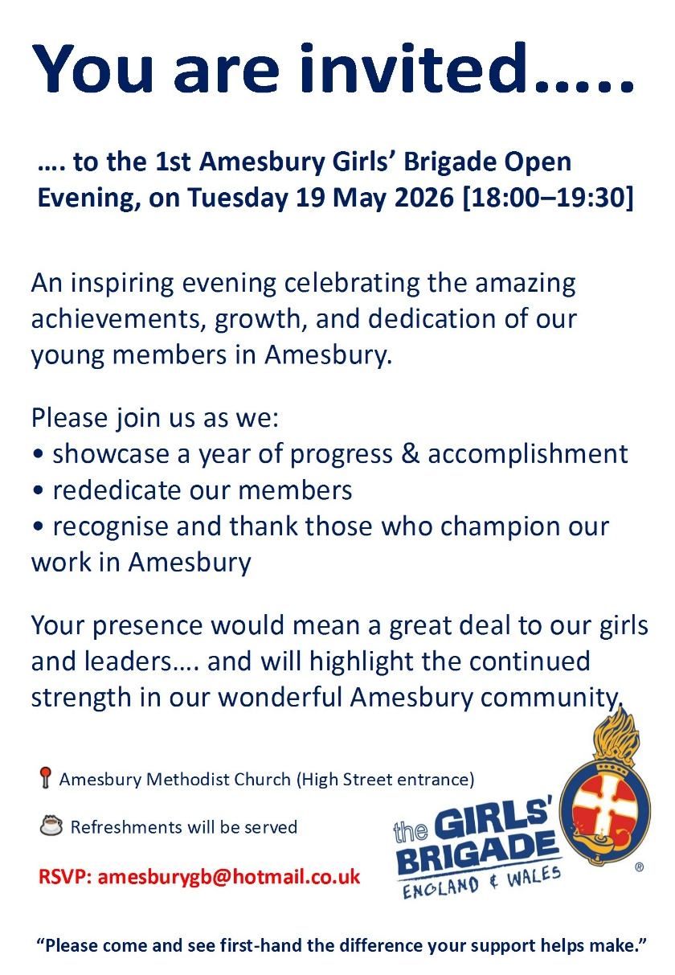

Girl’s Brigade would love to invite you to their open evening and their rededication of members. We hope that as many members of AMC will be able to attend.
Dcn. Selina Nisbett

Hall Bookings
For all bookings or enquiries contact Opal Webber the Community Hub Administrator who can be contacted on 07943 076007; or by email amesburymethchurch@gmail.com

We have 2 large Halls and a small Meeting Room available for hire: Ideal for Family Parties, Groups, Exercise Classes, Dance Groups, etc. The Kitchen is large, spacious, and well equipped and complies with all Health & Safety Regulations.
For more details Contact the Stewards
MONDAY | 10.00 – 12.00 BH Afghan Community Hub  13.30 - 16.00 MH Beyond Dementia (formally The Alzheimer’s Support Group)  19.30 – 21.30 BH Scottish Country Dancing | TUESDAY | 11.00 – 12:30 BH Line Dancing with Julie  11.00 – 13.00 MH The Salisbury Food Bank  14.00 – 16.00 BH The Amesbury Archer’s Songsters  18.15 – 20.15 ALL rooms Girls Brigade (Term-time only)
WEDNESDAY | 10.00 – 12.30 BH Pre-Natal Yoga  13.30 – 17.00 MH The Amesbury Bridge Group (every 3rd Wednesday of the month)  16:30 – 20.15 BH Line Dancing with Julie | THURSDAY | 11.00 – 12.30 BH Line Dancing with Julie  13.00 – 15.00 MH The Salisbury Foodbank  14.00 – 16.30 QR Bible fellowship (1st & 3rd dates of the month)
FRIDAY | Cleaning at 6.00 pm | SATURDAY | 10.00 – 11:30 MH Coffee morning 9th & 23rd May (2nd & 4th Saturday of the month)
BH = Back Hall, MH = Main Hall, YR = Youth Room, QR = Quiet Room

Amesbury Methodist Church CCLi licence no 206298.

