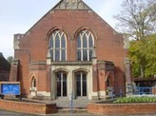
Salisbury Circuit 26/12
Amesbury Methodist Church
Minister: Deacon Selina Nisbett
email: selina.nisbett@methodist.org.uk 01980 669941
www.salisburymethodistcircuit.org.uk/churches/amesbury-methodist-church/
Newsletter for July & August 2026

Minister’s Letter

Dear Friends,

The months of July and August have often been associated with holidays; going to the beach or abroad, or sometimes precious visits to family or friends. Of course, as time has passed and finances are increasingly limited, holidays have become a real luxury for many. If we look back to the 1950s we realise that holidays as we have come to perceive them, have not always been the norm.

Take for example the people after World War 2, who regularly left smoggy London with all their goods and chattels, including their crockery, curtains and bedding, to travel to Kent. There they would set up home in little huts for a few weeks to pick hops. They earned some extra money, worked hard, but most of all it was freedom for the children, with trees to climb, fields to explore, space to play in and fresh air to breathe. Whilst it may not have been our idea of a holiday, it was a time of refreshment and renewal for the hoppers, who left the busy and bustling city for the relative peace of the Kent countryside.

Our word “holiday” derives from “holy days,” days of religious observance, celebrated initially by the early church with great solemnity and ritual, set apart for God. Just as we do Sunday by Sunday, people withdrew from their everyday tasks, and laid down their work, in order to worship, celebrate and to be renewed in the presence of God.

In Mark 6 we hear how life around Jesus and the disciples became increasingly frenetic, and Jesus sensing his disciples need for some rest and renewal said to them, “Come away to a deserted place all by yourselves and rest a while.”

This pattern of withdrawing to a quiet place to pray to discern, be renewed, and to be strengthened, was significant in the ministry of Jesus.
- we hear how he went in the early morning to a deserted place to pray
- as his popularity grew he withdrew from others to pray alone
- before choosing his apostles he went out to the mountain to pray and discern
- before asking the disciples who he was, he went to pray
- before his passion, Jesus withdrew to the Garden of Gethsemane, and prayed in great anguish to his Father.

This pattern of withdrawing to quiet places was foundational to Jesus ministry, and if it was so for him, how much more foundational is it for us? Throughout the ages, Christians have sought to imitate this pattern; it has helped them
- to reflect deeply
- to cultivate a personal relationship with God
- to receive spiritual renewal, wisdom and strength
- to demonstrate humility through dependence upon God
- and to discern God’s will for the way ahead

Praying is like taking a holiday from the world, to journey into the heart of God, and is the foundation upon which ministry and mission are begun. For the early Christians, prayer was not an optional extra but the foundation of their life together as it should be, ours. We are told in Acts 1 v 14, that they "all joined together constantly in prayer." Before the Church grew outwards in mission, it was first gathered in prayer. As roots are to a tree, prayer is to the Christian life—often unseen, but essential for growth, strength, and fruitfulness.

In September I will be inviting you to “come away” with me to a quiet place, to rest in God’s presence, to seek his wisdom, to grow in strength and to discern God’s call for us as we seek to build His Kingdom in this place.

In the meantime, whether you go away on holiday, or take little holidays/ “holy days” at home, I pray that you will journey safely, with our companion God by your side.

Love and God bless

Dcn SELINA


OUR ZAMBIA LINK

July and August are cool, dry months in Zambia. Travel is much easier, because the roads and tracks are dry. People have completed the harvest in July, and so this is the season when regional and national conferences and other gatherings are held.

This July and August, life in Zambia will be dominated by the elections – for President, for the National Assembly and for some local government posts. The number of National Assembly members is being increased by more than 40 percent, so 70 new constituencies have been created.

Pray for peace and integrity before and after Election Day – August 13th.
A good harvest is expected this year, and thanks for that will be given, nationally on the Farmers’ Day public holiday (August 3rd) and in church on Harvest Sunday (August 9th).
In our prayers, we join with the special Sundays in the life of the UCZ:
- UCZ University Sunday on 12th July: The UCZ University on the Copperbelt is where ministers, deaconesses and other church workers study and are trained. On this Sunday
congregations will hear about the work of the University and pray for staff and students.
- Men’s Christian Fellowship (MCF) Sunday on 19th July. In their distinctive red jackets, MCF members are vital to the witness, pastoral care and adult education of the UCZ. Give thanks for their ministry, and pray for continuing dedication.
- Stewardship Sunday on 26th July: The UCZ is self-reliant financially, and so each church member is called to give of their time, talents and money to sustain the mission of the church.

Please continue to pray for our link congregation, St Andrew’s, Lusaka, for the minister, Revd Theresa Matimba, and for her family and for the Girls’ Brigade company at St Andrew’s, as they pray for us.
Cecil King

Sunday March 16
the
Amesbury Church Anniversary Service led by Rev. Rachel
Bending
Sunday March 30
to
Mothering Sunday
Sunday March 16
to
Amesbury Church Anniversary Service led by Rev. Rachel
Bending
Sunday March 30
to
Mothering Sunday
Sunday March 16
to
Amesbury Church Anniversary Service led by Rev. Rachel
Bending
Sunday March 30
the
Mothering Sunday
Services for July & August - Please pray for all those leading worship

- Sunday 5th July 10.30 am - Morning Worship - David Bradberry
- Sunday 12th July 10.30 am – Morning Worship - Valerie Liversidge
- Sunday 19th July 10.30 am - Holy Communion - Revd Richard Smith
- (Sunday 19th Junior Church End of Year Celebration)
- Sunday 26th July 10.30 am - Morning Worship with our GB and BB friends from Zambia - Dcn Selina Nisbett
- Sunday 2nd August 10.30 am - Morning Worship - John Pipet
- Sunday 9th August 10.30 am - Holy Communion - Revd David Hollingsworth
- Sunday 16th August 10.30 am - Morning Worship - Sue Holmes
- Sunday 23rd August 10.30 am - Morning Worship (Leprosy Mission)
- Sunday 30th August 10.30 am - Morning Worship - Dc Selina Nisbett

NB There will be some dates coming out for the 6 week course over the summer at AMC for those in the second half of life. We are just waiting to secure a booking for this and flyers will be coming out to advise you of the dates and times. The topics covered are memories, relationships and identity, wisdom, forgiveness and reconciliation, death and dying and celebrating life.

We extend a warm welcome to all and invite you to stay for refreshments, which will be served after the morning service. We usually take the Offering by having a plate in the Vestibule on your arrival to church and the Welcome Steward brings it up in the first hymn where the offering is dedicated during the Service. You can set up a Standing Order HSBC, Amesbury Methodist Church, Sort code: 40-08-25 Account No: 61117300
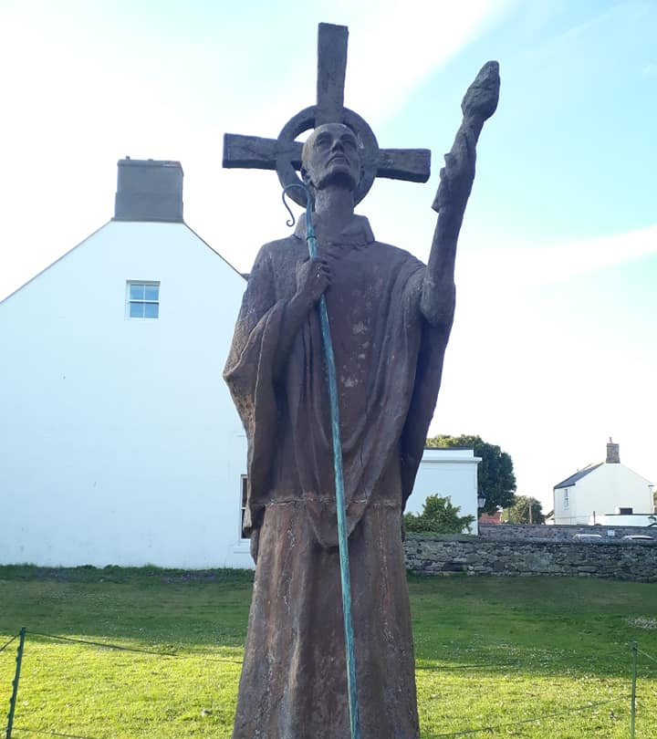
A PRAYER FROM ST AIDAN OF LINDISFARNE
about the rhythm of retreat and return in prayer

Leave me alone with God as much as may be.
As the tide draws the waters close in upon the shore,
Make me an island, set apart,
Alone with You, O God, holy to You.
Then with the turning of the tide
Prepare me to carry Your presence to the busy world beyond,
The world that rushes in on me,
Till the waters come again and take me back to You.

PRAYER REQUESTS FROM OUR SISTERS AND BROTHERS IN ZAMBIA
- As people enjoy the Heroes and Unity public holidays (6 & 7 July), pray that in the election campaigning national unity will prevail and the freedom for which the nation's heroes struggled will be sustained.
- Pray for the lay leaders gaining leadership training in Lusaka Presbytery next weekend (3-5 July).
- Pray for all the pupils, teachers and leaders involved in the schools retreat (4-7 July).
- At St Andrew's, pray for the minister, Revd Theresa Matimba, and her family and for the officers and girls of the Girls' Brigade, as they pray for us.

I am delighted to share the following letter from Whiteson Chenge from the UCZ church who visited us in the spring…….
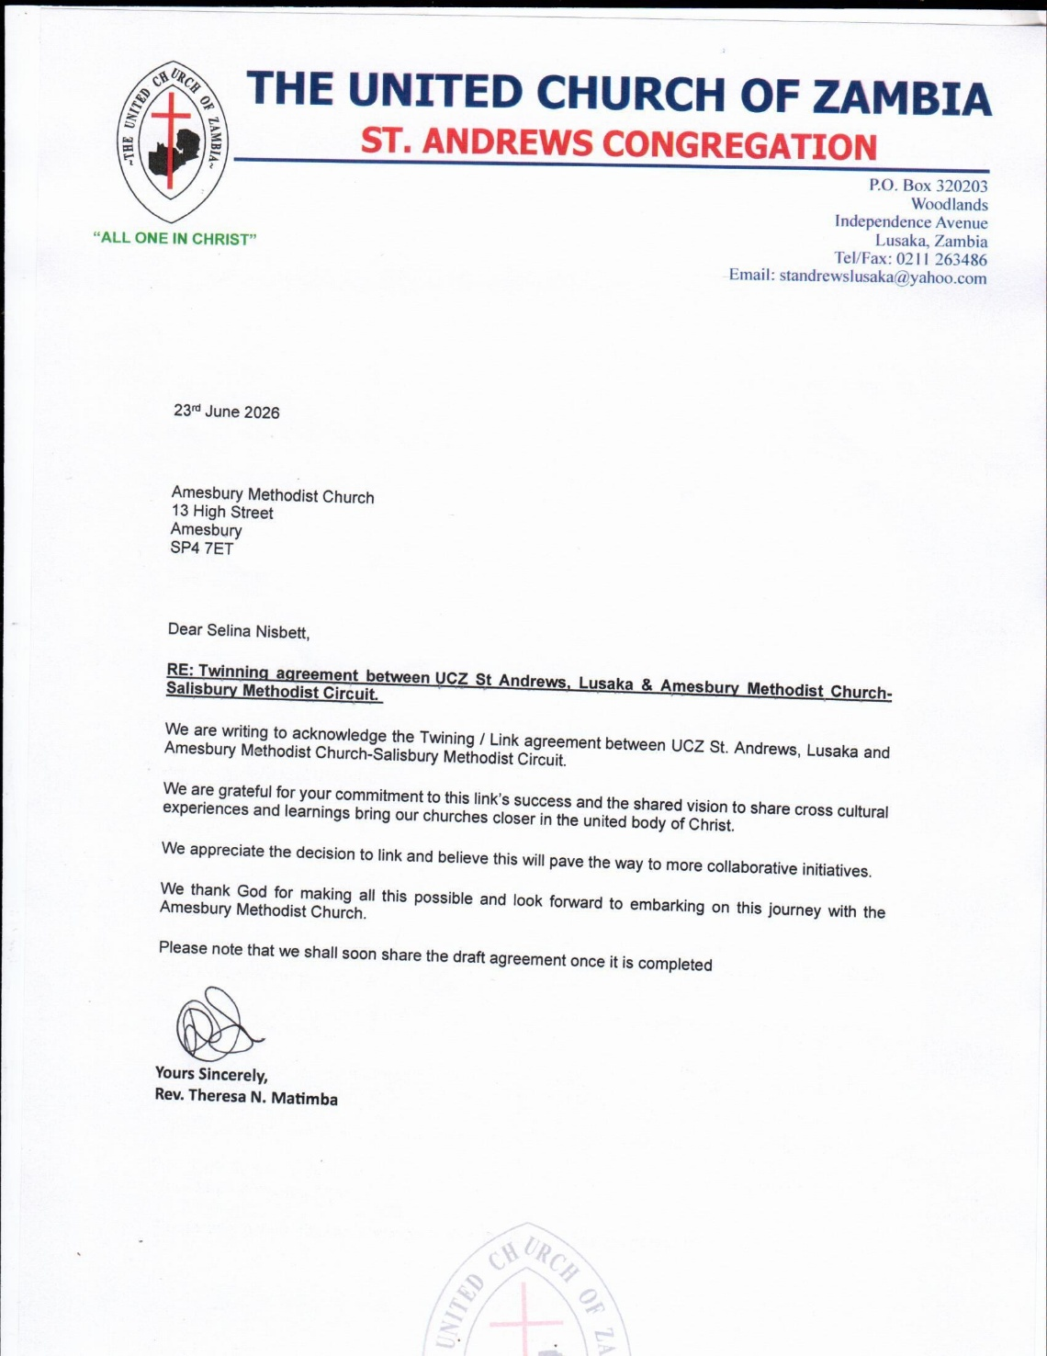

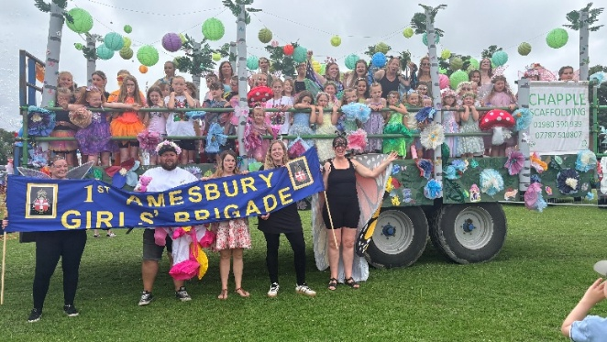
NEWS FROM OUR GIRLS’ BRIGADE
On the 20th June 2026, 1st Amesbury Girls’ Brigade entered a ‘fantasy and fairytales’ float into the Annual Amesbury Carnival; where we were awarded the ‘Spirit of Carnival’ award.
In the weeks leading up to the carnival, our girls, leaders, and a super dedicated parent’s army made flowers, toadstools, animals, trees, leaves, staging and lots of other things to bring our chosen theme alive. The creation of the float was a massive team effort.
Special thanks must go to our local farmer who donated his time, tractor and trailer for Girls’ Brigade to go mobile on the day. We had an incredible 50 girls and leaders take part – and everyone came dressed up in the theme for the day.
It is also important to thank Amesbury Filling Station, Wickes DIY and Chappel Scaffolding for helping with the big stuff!
On the day, we had an early start with lots of very excited girls and leaders all dressed up and ready to sing, dance and wave as we travelled through the streets of Amesbury. We shouldn’t forget to thank the parents who led our entry by dressing up and holding a 1st Amesbury Girls’ Brigade banner whilst walking around our tractor and trailer float.
It really was a fantastic day. A massive thank you to everyone who supported us and helped make our entry possible.
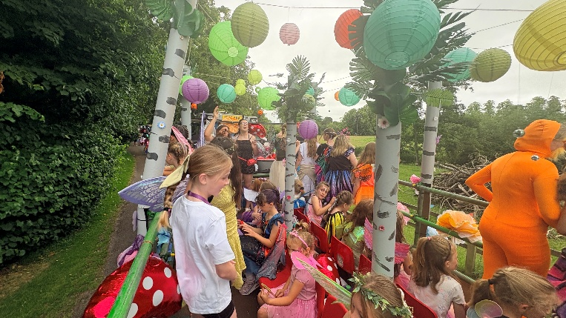
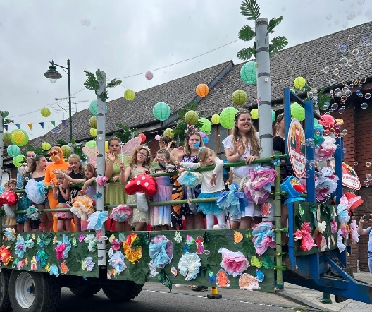
1st Amesbury Girls’ Brigade
Many congratulations to our GB for receiving the Spirit of the Carnival award! It was very well deserved! We wish all of our GB leaders, girls and their families a very happy and safe summer break! Dcn Selina


Hall Bookings
For all bookings or enquiries contact Opal Webber the Community Hub Administrator who can be contacted on 07938711049; or by email amesburymethchurch@gmail.com

We have 2 large Halls and a small Meeting Room available for hire: Ideal for Family Parties, Groups, Exercise Classes, Dance Groups, etc. The Kitchen is large, spacious, and well equipped and complies with all Health & Safety Regulations.
For more details Contact the Stewards
MONDAY | 10.00 – 12.00 BH Afghan Community Hub  13.30 - 16.00 MH Beyond Dementia  19.30 – 21.30 BH Scottish Country Dancing | TUESDAY | 11.00 – 12:30 BH Line Dancing with Julie  11.00 – 13.00 MH The Salisbury Food Bank  14.00 – 16.00 MH The Amesbury Archer’s Songsters  18.15 – 20.15 ALL rooms Girls Brigade (Term-time only)
WEDNESDAY | 10.00 – 12.30 BH Pre-Natal Yoga  16:30 – 20.15 BH Line Dancing with Julie | THURSDAY | 11.00 – 12.30 BH Line Dancing with Julie  13.00 – 15.00 MH The Salisbury Foodbank  14.00 – 16.30 QR Bible fellowship (1st & 3rd dates of the month)
FRIDAY | Cleaning at 6.00 pm | SATURDAY | 10.00 – 11:30 MH Coffee morning (2nd & 4th Saturday of the month)
BH = Back Hall, MH = Main Hall, YR = Youth Room, QR = Quiet Room

Amesbury Methodist Church CCLi licence no 206298.

