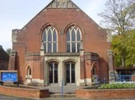
Salisbury Circuit 26/12
Amesbury Methodist Church
Minister: Deacon Selina Nisbett
email: selina.nisbett@methodist.org.uk 01980 669941
www.salisburymethodistcircuit.org.uk/churches/amesbury-methodist-church/
Newsletter for October 2026

Minister’s Letter
Dear Friends,
Between September and the 4th October, (set aside by some denominations as the feast day of St Francis of Assisi), the church is encouraged to mark Creation Time, when we are invited to pause and give thanks for the wonderful gift of God’s creation. It calls us to be mindful of all life upon our precious earth, and of our responsibility to care for our common home.
Francis saw creation, and all living creatures as God’s gifts to be cherished. He gave up a life of opulence for one of poverty, ministering to those on the margins of society. The stories of his encounters with animals, the way in which he spoke of Brother Sun, Sister Moon, and Mother Earth, together with his care of those with leprosy, demonstrate that care for creation cannot be separated from care for people, and teaches us that we are part of one beautiful human family, wonderfully diverse, but united in God’s love.
October is also Black History Month, when we remember, celebrate and learn from the experiences and contributions of Black people throughout history, giving great thanks for the many individuals whose faith, courage, creativity and determination have enriched and continue to enrich our churches, communities and wider society.
As Christians, we are called to recognise the God-given dignity of every person, remembering that just as creation itself is so diverse, so too is the family of God, to which we belong, and our differences are beautiful gifts to be celebrated and which can help us learn from one another, broaden our understanding and become a more loving and welcoming people.
St Francis’ famous prayer begins, “Lord, make me an instrument of your peace.” These words challenge us to consider how we can truly be people of peace, caring for the earth, standing alongside those who experience injustice, celebrating diversity and reaching out to those who feel excluded or forgotten.
As we mark Creation Time and Black History Month, may we give thanks for the beauty and diversity of God’s creation, celebrate the gloriously diverse family to which we all belong, and in these troubled times, may we like Francis, live more gently upon the earth and peaceably alongside one another.

With love and blessings
Dcn Selina

A PRAYER FOR BLACK HISTORY MONTH
God of all nations,
We thank you for the rich heritage, faith, resilience, and achievements of Black people throughout history.
We remember those who endured injustice, challenged inequality, and worked tirelessly to build a more just and compassionate society.
May their courage inspire us to value every person as made in your image.
Help us to celebrate diversity, stand against racism in all its forms, and work together for justice, peace, and reconciliation.
Unite us in love, strengthen us in hope, and guide us to build communities where everyone can flourish.
This we ask through Jesus Christ our Lord. Amen


OUR ZAMBIA LINK
October is the hottest month in Zambia, when, astonishingly, green shoots begin to appear, even though it has not rained since April. We, with the people of Zambia, pray that the rains will come in November.
And October is the month when Zambia celebrates the nation’s independence. The new nation of Zambia was born on October 24th, 1964.
But this 62nd anniversary may be less joyful than usual, because, following the general elections on August 13th, the country is bitterly divided and subject to unprecedented criticism internationally for the conduct of the elections and the treatment of opposition politicians who dispute the official results.
Election observers from the European Union criticised the conduct of the elections and the counting of the votes. Amnesty International has highlighted the detention without trial of opposition politicians. The Secretary General of the Commonwealth has condemned the treatment of opposition leaders after the election.
The re-elected government say that a meeting of opposition leaders was planning the violent overthrow of the government and accuses them of treason. They are detained – but one of them (a former government minister) was shot dead by security forces. People inside and outside Zambia are disturbed about the conditions under which the detainees are being held.
Pray for justice, reconciliation and peace in Zambia. Pray for the churches in Zambia, praying and working for reconciliation. Pray for the people of Zambia living in heightened tension not known since the armed incursions from Rhodesia (now Zimbabwe) nearly 50 years ago.
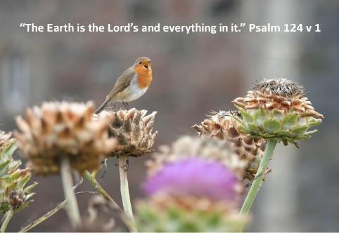
October 18th in Zambia will be a national Day of Prayer, Fasting, Repentance and Reconciliation. Join the people of Zambia that day in prayer for the nation.
Please continue to pray for our linked congregation of the United Church of Zambia – St Andrew’s in Lusaka, and pray for the minister there – Revd Theresa Matimba and her family, and remembering especially the people from St Andrew’s who have visited us this year – the Girls’ Brigade members and Mr Whiteson Chenge.
Cecil King
Sunday March 16
the
Amesbury Church Anniversary Service led by Rev. Rachel
Bending
Sunday March 30
to
Mothering Sunday
Sunday March 16
to
Amesbury Church Anniversary Service led by Rev. Rachel
Bending
Sunday March 30
to
Mothering Sunday
Sunday March 16
to
Amesbury Church Anniversary Service led by Rev. Rachel
Bending
Sunday March 30
the
Mothering Sunday
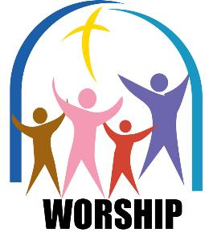
Services for October - Please pray for all those leading worship

- Sunday 4th October 10.30 am - Morning worship – Fi Waddingham
- Sunday 11th October 10.30 am - Holy Communion – Rev’d Ros Hollingsworth
- Sunday 18th October 10.30 am - Morning Worship - John Pipet
- Sunday 25th October 10.30 am - Morning Worship - Rev’d Dr Peter Howson
- Sunday 1st November 10.30 am - All Souls Service - Dcn. Selina Nisbett

We extend a warm welcome to all and invite you to stay for refreshments, which will be served after the morning service. We usually take the Offering by having a plate in the Vestibule on your arrival to church and the Welcome Steward brings it up in the first hymn where the offering is dedicated during the Service. You can set up a Standing Order HSBC, Amesbury Methodist Church, Sort code: 40-08-25 Account No: 61117300

The flower team are looking for a few more people to join the rota. Please let Gillian Clarke know if you would like to join. It is always lovely to have flowers on a Sunday and to minister to others through their distribution.

THE PRAYER GROUP 2nd and 4th Saturday in the month at 9.30am in the church
PRAYER DIARIES – in the Welcome area, please take one to use.

HISTORY CENTRE
There are a lot of interesting events happening at the Amesbury History Centre in October. Please see the link here: www.amesburyhistorycentre.org.uk

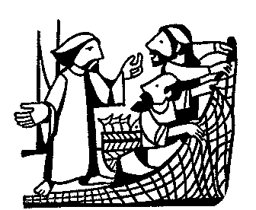
On the shore
The nets were sodden and stringy,
taut against our fingers,
the fish roiling and flicking silver
as we drew them in.

It was a good catch.

Then he’s at my shoulder
and goes
‘Leave this, and follow me’

You’d laugh, wouldn’t you?
You’d be thinking - what’s he on about?
You’d mutter ‘push off, and let me get on’

But I didn’t
We didn’t

We dropped the nets and left the fish
just there, on the shore
we left it all
and followed him

It was a good catch

(Thank you to Susie for this beautiful poem)
Independence Prayer – Zambia
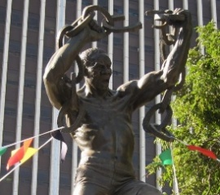
The Zambian Independence Prayer was written alongside the celebration of independence on 24 October 1964.

Contemporary version
Almighty and Eternal God,
Creator and Protector of all people,
into your hands we commend our land of Zambia.
Draw into closer unity the people of all races who dwell here.
Send out your light and your truth that they may lead us into paths of community and peace.
Deliver us from the pride that fears not God and the selfishness that disregards humanity.
And grant that political freedom may, by your blessings, be an instrument for good to us and to the nations of the world.
Strengthen us, we beseech you, that we may fulfil the Law of Love and so continue, as a place and a people, to serve you to the end of time.
Through Jesus, our Saviour and Redeemer. Amen.

A Prayer for United Nations Day
Heavenly Father,
We come before You with grateful hearts as we celebrate United Nations Day, honouring the bonds of peace, unity, and cooperation among all nations.
Thank You for the gift of diversity—for the rich cultures, languages, and traditions that beautify our world. Remind us that we are one global family, and regardless of our borders or backgrounds, we are all touched by Your grace.
Guide the leaders of the nations and all who serve within the United Nations. Grant them wisdom, patience, and compassion to choose peaceful resolutions over division, and to make decisions that uphold human rights, justice, and safety for everyone.
Give us the courage to be peacemakers in our own local communities—caring for the poor, standing up for the oppressed, and spreading understanding wherever we go.

May the world we shape together reflect Your compassion and bring lasting harmony to all people.

Amen.

From the Presbyterian Church of the USA
https://pcusa.org/resource/prayer-united-nations-day



Hall Bookings
For all bookings or enquiries contact Opal Webber the Community Hub Administrator who can be contacted on 07949 076007; or by email amesburymethchurch@gmail.com

We have 2 large Halls and a small Meeting Room available for hire: Ideal for Family Parties, Groups, Exercise Classes, Dance Groups, etc. The Kitchen is large, spacious, and well equipped and complies with all Health & Safety Regulations.
For more details Contact the Stewards
MONDAY | 10.00 – 12.00 BH Afghan Community Hub  13.30 - 16.00 MH Beyond Dementia  19.30 – 21.30 BH Scottish Country Dancing | TUESDAY | 11.00 – 12:30 BH Line Dancing with Julie  11.00 – 13.00 MH The Salisbury Food Bank  14.00 – 16.00 MH The Amesbury Archer’s Songsters  18.15 – 20.15 ALL rooms Girls Brigade (Term-time only)
WEDNESDAY | 09.00 – 11.00 Baby stay and play  16.00 – 18.00 MH Kelly’s dance class  16.30 – 20.15 BH Line Dancing with Julie | THURSDAY | 11.00 – 12.30 BH Line Dancing with Julie  13.00 – 15.00 MH The Salisbury Foodbank  14.00 – 15.30 QR Bible Study
FRIDAY | Cleaning at 6.00 pm | SATURDAY | 10.00 – 11:30 MH Coffee morning (2nd & 4th Saturday of the month)
BH = Back Hall, MH = Main Hall, YR = Youth Room, QR = Quiet Room

Amesbury Methodist Church CCLi licence no 206298.

