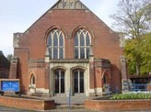
Salisbury Circuit 26/12
Amesbury Methodist Church
Minister: Deacon Selina Nisbett
email: selina.nisbett@methodist.org.uk 01980 669941
www.salisburymethodistcircuit.org.uk/churches/amesbury-methodist-church/
Newsletter for September 2026

Minister’s Letter

Dear Friends,
At our last Annual Church Meeting we were reminded of the words of Jesus to "Let your light shine before others, so that they may see your good works and glorify your Father in heaven." This command emphasizes the importance of living a life that reflects Christ's character who brought light into the darkness of our world.
When we read the news, we can easily feel completely disempowered by the darkness of the world, and wonder how our little light could possibly make a difference, but Mother Theresa of Calcutta offered some very wise advice. She said;
“We ourselves [may] feel that what we are doing is just a drop in the ocean. But the ocean would be less because of that missing drop…..[And] never worry about numbers. Help one person at a time, and always start with the person nearest you.”
When we come through our Church doors on a Sunday, and interact with one another, we never really know what another person is carrying behind their smile. There may be grief, worry, loneliness, family difficulties or the pure exhaustion of getting through another week. Looks can be so deceptive, which is why the pastoral care of one another is so important. It is not just about visiting when people are ill, it is also about being sensitive to needs, noticing one another, listening to one another and making sure that people know they are valued and that they belong. It is quite simply, one of the ways we can proclaim God’s love.
We should be particularly mindful of parents coming to church with little ones. Bringing infants to church is not easy; I remember so well the anxiety that I felt when my children were small, and made a noise, or became rather restless, but of course I soon learned, through the patience and understanding of others, that my crying baby or my wandering toddler was not an interruption to worship, and not a problem to be “managed”, but that we were in fact, an important part of God’s glorious family! This is why we now give out welcome cards to those with little ones and contact cards to new people of any age.
Pastoral care is not the sole responsibility of our pastoral visitors; it belongs to all of us in our church family. It happens when a Junior Church leader notices that a child seems unusually quiet, or when someone lingers behind after worship to talk; it happens when we remember someone's name, and ask how they are, and listen with sincerity, pray for them faithfully, and show our genuine concern.
Pastoral care is of great significance in The Methodist Church, and at the beginning of the new Connexional year, which starts on the 1st Sept, there is usually an opportunity to rededicate and affirm those who formally exercise this ministry. It is always an important moment for the church as we give thanks for those who offer their time, energy, gifts and care to others, as well as giving us an opportunity to pray for them and rededicate ourselves to pastoral care more generally. It is a powerful reminder to us, that the church is not simply a building where we come to worship, but a community that follows the command of Jesus “to love one another.”
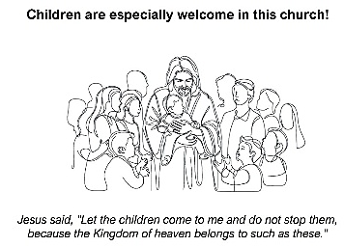
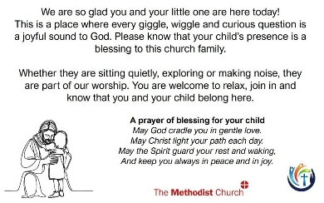
So, as we look ahead, to this new year, may we become even more intentional about the welcome we offer to one another, the way we listen to each other, and the way we make room for one another and pray for one another. May we be a church where the grief stricken finds compassion, where the lonely finds friendship, where judgement gives way to understanding, and where every person who walks through our doors, sees our light shining and encounters the abundant love of God.
With love and blessings
Dcn.Selina Nisbett


OUR ZAMBIA LINK

At the time of writing (August 19th), the results and consequences of the presidential, parliamentary and local elections on August 13th are not known. Controversy surrounds the fairness of the elections and of the vote counting. It is reported that Hakainde Hachilema has been elected for a second five year term as President oif Zambia. Continue to pray for the people of Zambia – for peace, and that the people elected – to the National Assembly and to local government - and will work together honestly for the common good.

We are linked with the United Church of Zambia (UCZ) in Lusaka, where the growth in the number of members and the number of congregations has led to the creation of a new presbytery (equivalent of district in British Methodism). Lusaka Presbytery has been split; a new Lusaka East Presbytery has been created. Pray for the Bishop of Lusaka East Presbytery, the Revd Harriet Kaira Kapeya, and for the presbytery secretary, the Revd Cynthia Kabanda Shanzi. Our linked congregation – St Andrew’s - is in Lusaka East Presbytery.

September 6th is Temperance Sunday, praying for people who are addicted or who spend a high proportion of their wage on beer and seeking to persuade people away from drinking too much.

September 20th is Health Sunday, praying especially for the ministry of the UCZ in the two rural hospitals and seven health clinics the church runs, amid shortages of medicines and equipment and continuing widespread malaria and HIV/AIDS. Pray for the health and healing ministry of the UCZ and for the Revd Emmanuel Bwalya, UCZ Health Secretary,
in his work to ensure that the church hospitals and clinics have the staff, equipment and supplies that they need.

Pray especially this month for school pupils beginning their final term before school leaving examinations, especially the pupils at St Andrew’s School.
Continue to pray for our linked congregation – St Andrew’s - for the minister, the Revd Theresa Matimba, and her family. Give thanks for the safe return home of the friends from St Andrew’s who visited us in July.

Cecil King


Sunday March 16
the
Amesbury Church Anniversary Service led by Rev. Rachel
Bending
Sunday March 30
to
Mothering Sunday
Sunday March 16
to
Amesbury Church Anniversary Service led by Rev. Rachel
Bending
Sunday March 30
to
Mothering Sunday
Sunday March 16
to
Amesbury Church Anniversary Service led by Rev. Rachel
Bending
Sunday March 30
the
Mothering Sunday
Services for September - Please pray for all those leading worship

- Sunday 6th September 10.30 am - Holy Communion – Rev’d David Hollingsworth
- Sunday 13th September 10.30 am - Morning Worship and rededication of our Pastoral Visitors and Junior Church Leaders - Dcn. Selina Nisbett
- Sunday 20th September 10.30 am - Morning Worship - Rev’d Dorothy Piper
- Sunday 27th September 10.30 am - Harvest Festival – ALL AGE WORSHIP - Mrs Gwen Leslie

IMPORTANT DATES
- Junior Church resumes Sunday 6th Sept
- Church Council now on MONDAY 28th September @ 7.30

We extend a warm welcome to all and invite you to stay for refreshments, which will be served after the morning service. We usually take the Offering by having a plate in the Vestibule on your arrival to church and the Welcome Steward brings it up in the first hymn where the offering is dedicated during the Service. You can set up a Standing Order HSBC, Amesbury Methodist Church, Sort code: 40-08-25 Account No: 61117300


CHURCH FAMILY NEWS
We rejoice that Ann has become a Great Grandma to baby Summer!
May God bless her and may she bring an abundance of blessings to the whole family.
We send our love and congratulations.

PRAYER MINISTRY
As part of our commitment to good pastoral care, I would like to be able to offer prayer ministry after the service for anyone who would like to be prayed for CONFIDENTIALY. Ideally it would be good to have at least three of us. If you are interested please let me know. Please also look out for our church prayer diary.
On the 2nd and 4th Saturday a prayer group will meet in the church from 9.30 am -10 am. This is to help us pray for one another and for the mission of the church. If you would like to join please just come along!

ZAMBIAN GIRL’S BRIGADE VISIT
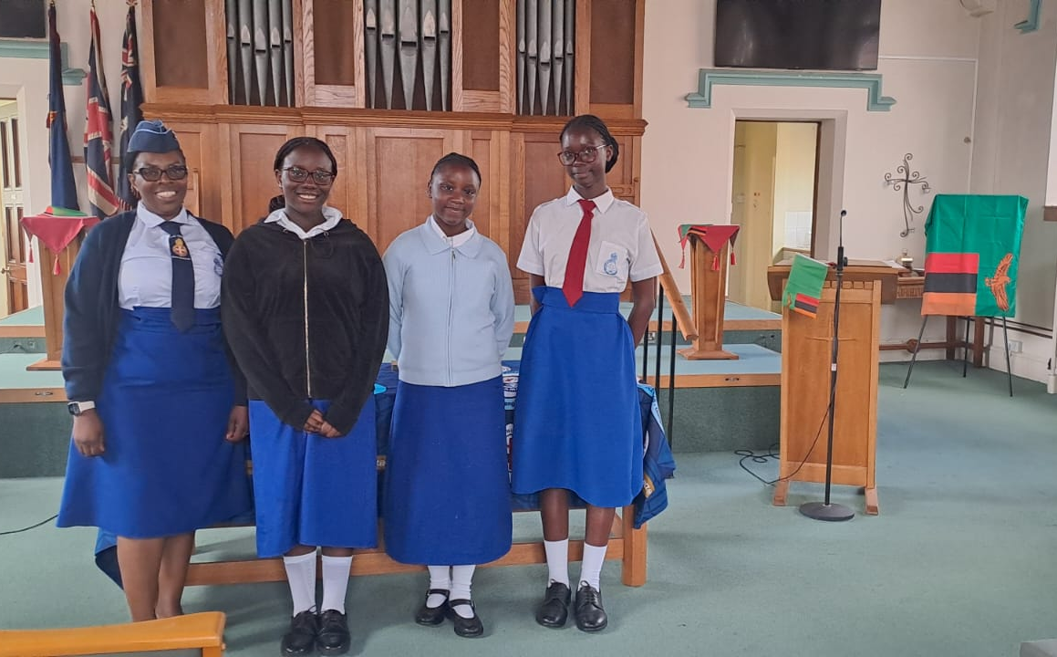
During the summer, Priscilla brought 3 of her girls from Girl’s Brigade from St Andrews UCZ Church in Lusaka, Zambia. The service was superbly and joyfully led by our older Junior Church members. Priscilla, Namwezi, Lolanji, and Chloe also participated in the service by telling us something about life in Zambia and about their girl’s brigade! They were thrilled to see the Girl’s Brigade panels in the hall and were especially touched to see their national flag incorporated into the mosaic. We had a most enjoyable lunch together and discovered we had many things in common. They spent some time at Youlbury Scout Camp near Oxford, went to the seaside, which was a first for some as Zambia is a landlocked country, and also went sightseeing in various places, including experiencing Evensong at Salisbury Cathedral. We had such a joyful time together and will be furthering our links with the UCZ church as we seek to establish some Bible study groups between our Junior Churches via zoom. Please continue to pray for the flourishing of this endeavour as we learn and grow together in discipleship and for all our brothers and sisters at St Andrews, Lusaka.

The Well is the Armed Service Project funded by the Salisbury Methodist Circuit and The Aldershot Methodist Military Trust. Please pray for this endeavour and our armed service families as we begin to roll this out in Larkhill, Bulford and Tidworth. Please feel free to share the information with those who may find this helpful. Thank you. Dcn Selina Nisbett

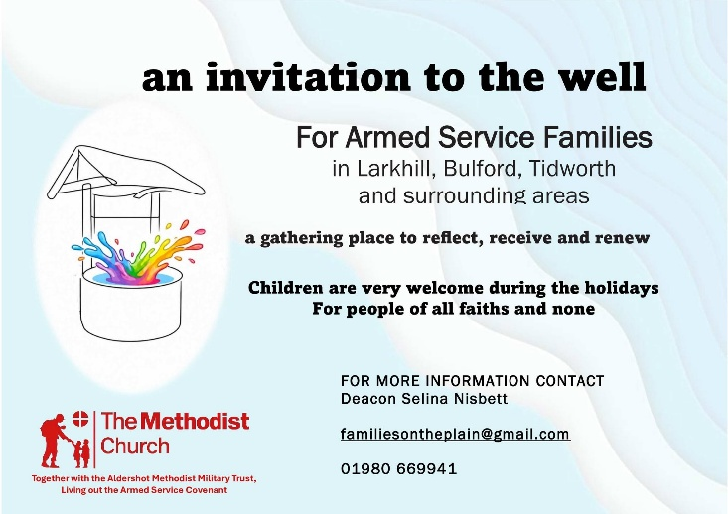

Hall Bookings
For all bookings or enquiries contact Opal Webber the Community Hub Administrator who can be contacted on 07938711049; or by email amesburymethchurch@gmail.com

We have 2 large Halls and a small Meeting Room available for hire: Ideal for Family Parties, Groups, Exercise Classes, Dance Groups, etc. The Kitchen is large, spacious, and well equipped and complies with all Health & Safety Regulations.
For more details Contact the Stewards
MONDAY | 10.00 – 12.00 BH Afghan Community Hub  13.30 - 16.00 MH Beyond Dementia  19.30 – 21.30 BH Scottish Country Dancing | TUESDAY | 11.00 – 12:30 BH Line Dancing with Julie  11.00 – 13.00 MH The Salisbury Food Bank  14.00 – 16.00 MH The Amesbury Archer’s Songsters  18.15 – 20.15 ALL rooms Girls Brigade (Term-time only)
WEDNESDAY | 16:30 – 20.15 BH Line Dancing with Julie | THURSDAY | 11.00 – 12.30 BH Line Dancing with Julie  13.00 – 15.00 MH The Salisbury Foodbank  14.00 – 16.30 QR Bible fellowship (1st & 3rd dates of the month)
FRIDAY | Cleaning at 6.00 pm | SATURDAY | 10.00 – 11:30 MH Coffee morning (2nd & 4th Saturday of the month)
BH = Back Hall, MH = Main Hall, YR = Youth Room, QR = Quiet Room

Amesbury Methodist Church CCLi licence no 206298.

